Some what seasonality

Plotting individually is hard

Potly expresses

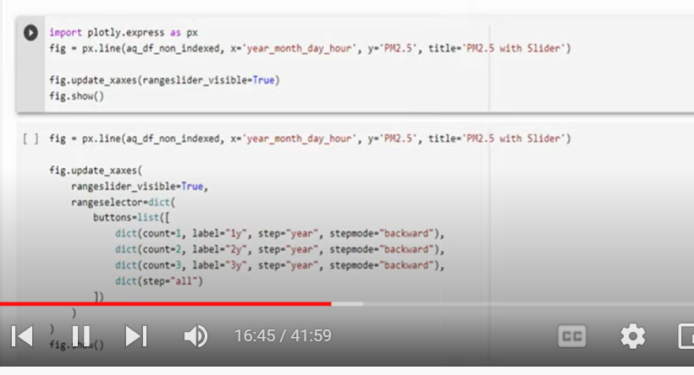

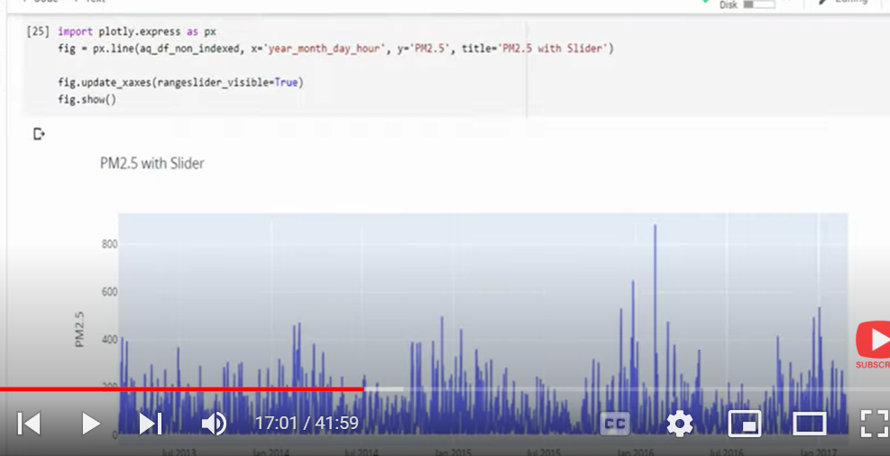

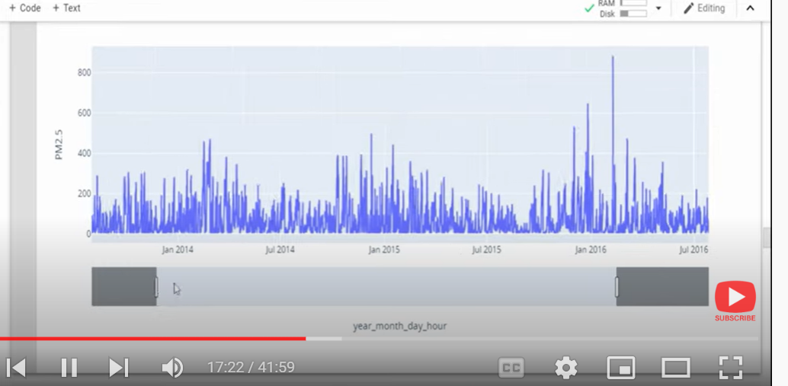

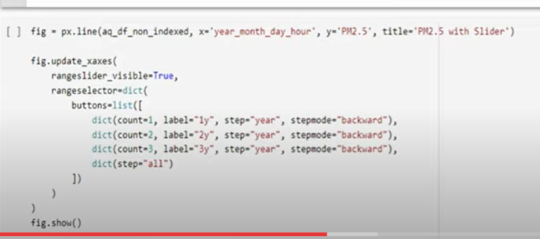

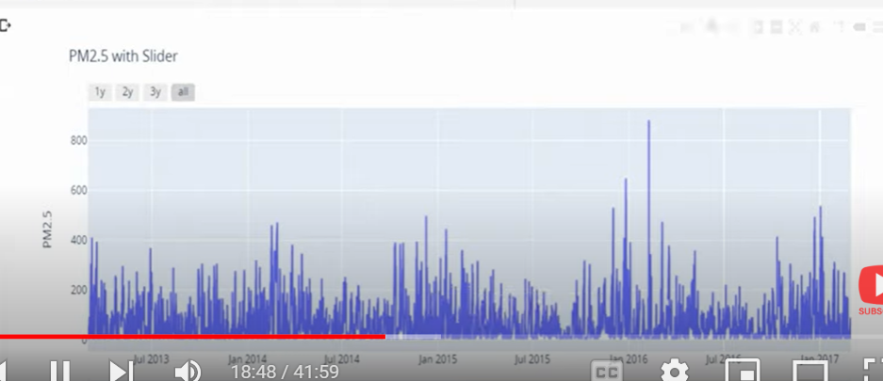

Overlapping two years

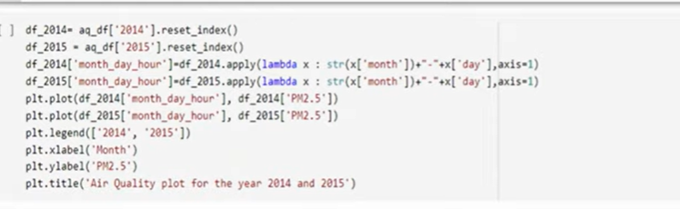

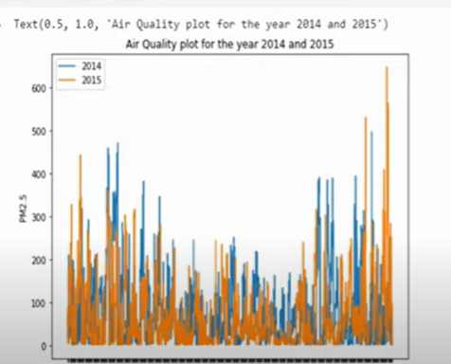

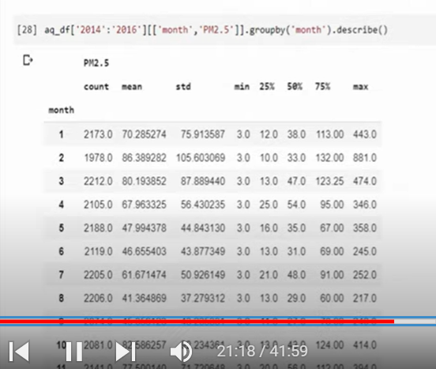

Bivariant



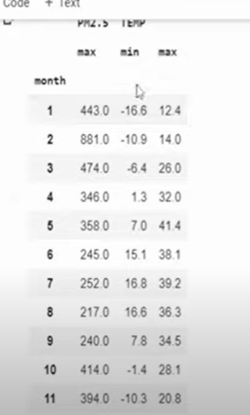

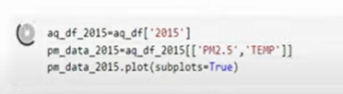

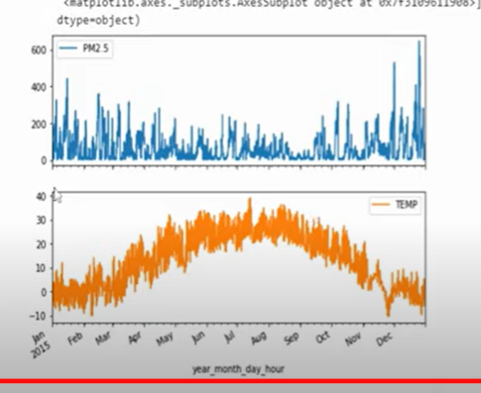

Pm2 high in winter

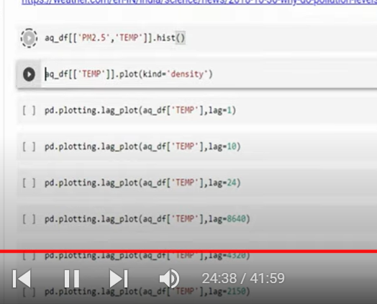

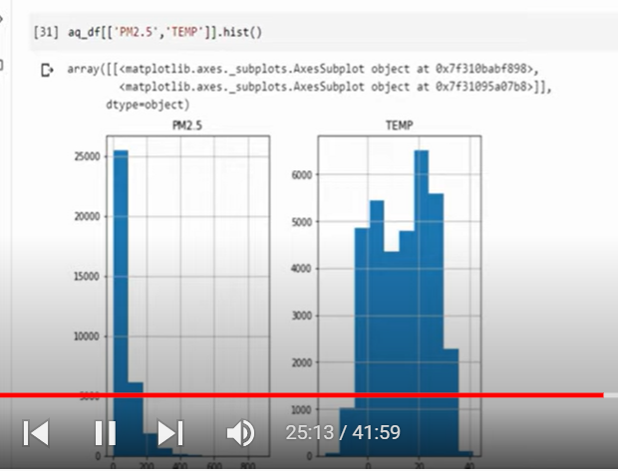

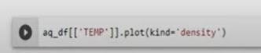

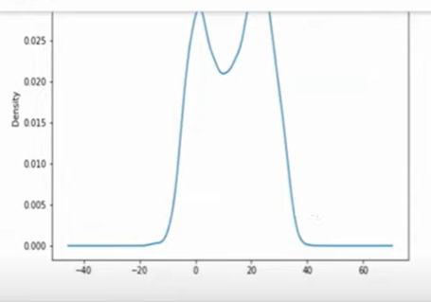

Lag plot is special type of scatter plot

X= current time

Y= lag period

Lag 1= one time period(1st order lag plot)

Lag=2 second order lag plot

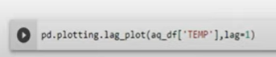

To check linearity

Linear shape= auto regressive

Outliers

Randomness

Serial or auto correlation

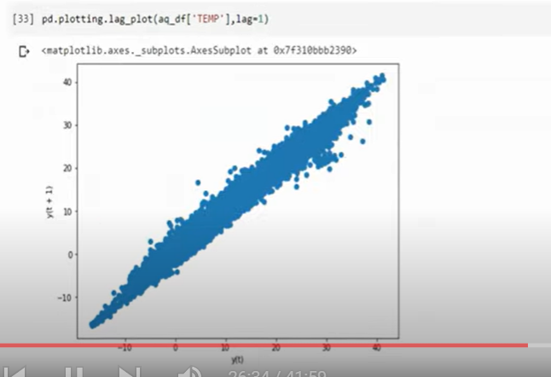

Linear relationship with one hour lag

Lag=10

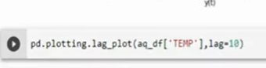

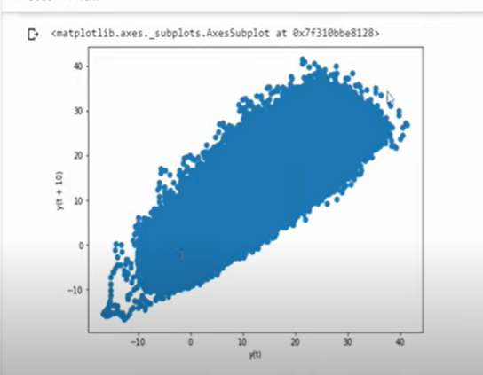

Data is not linear as above

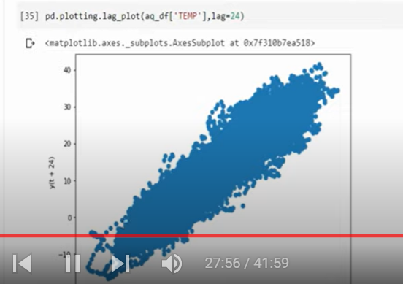

Auto correlation:

Correlation within itself

It is positive linear correlated

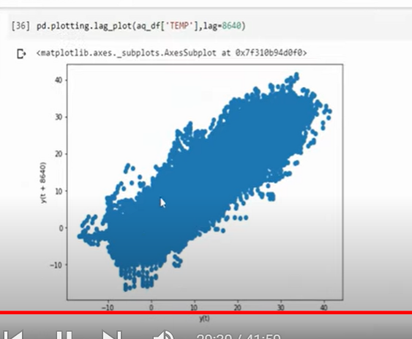

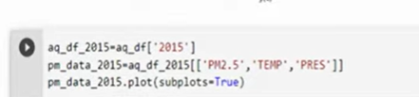

Multi variate

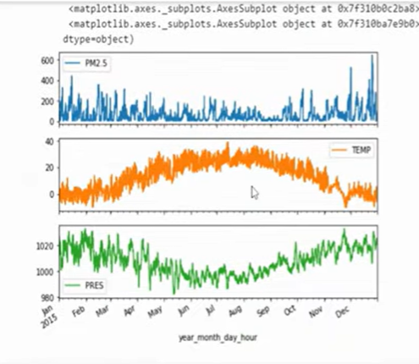

Temp is negatively correlated to temp

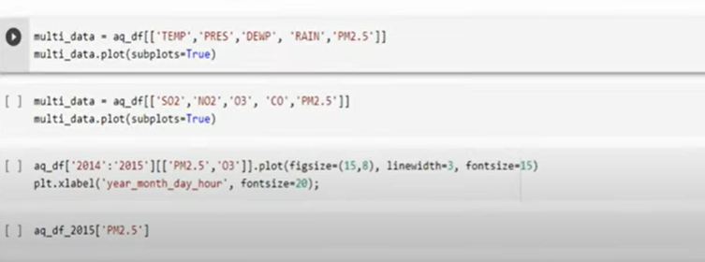

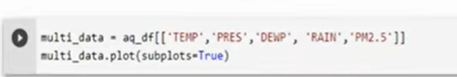

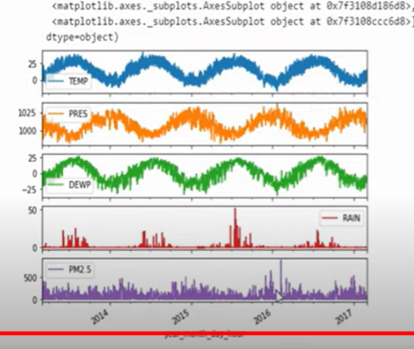

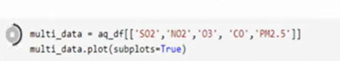

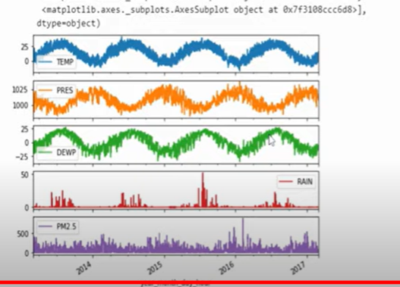

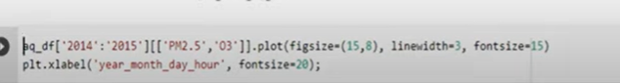

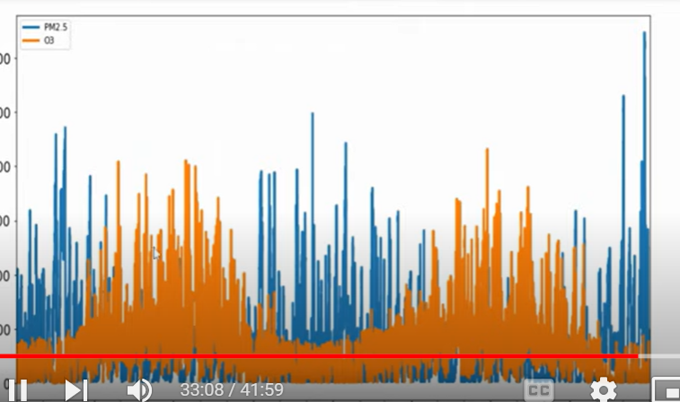

High o3 low pm

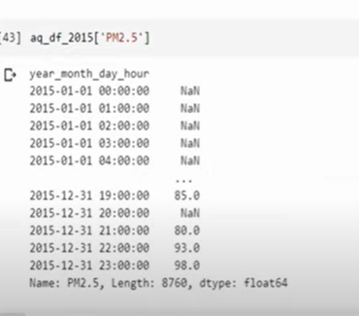

Lot of null values

Time series should be continuous

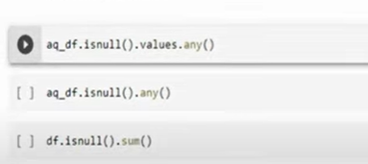

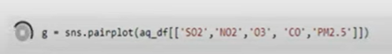

Pairplot to see correlation

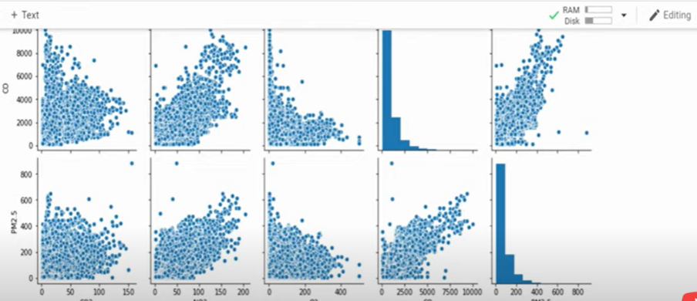

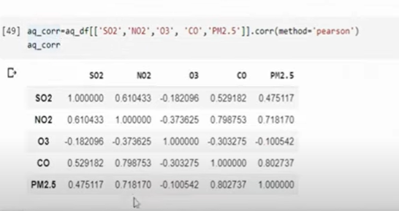

Pearson correlation

Heatmap

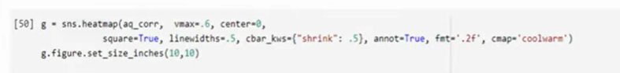

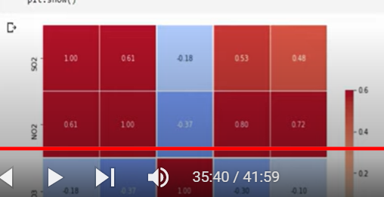



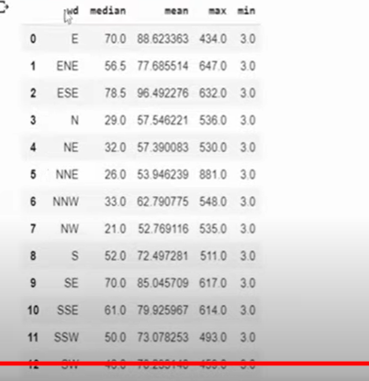

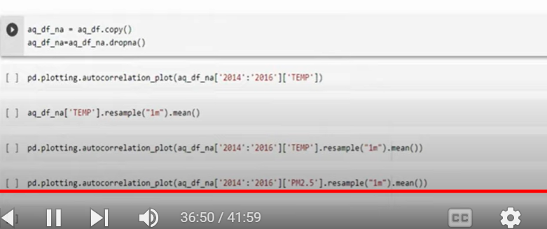

ACF plot

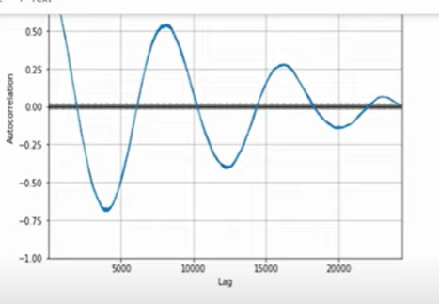

Positive again in 8500 hours means after one year

So its better to check monthly correlation

For this we need to go for resampling

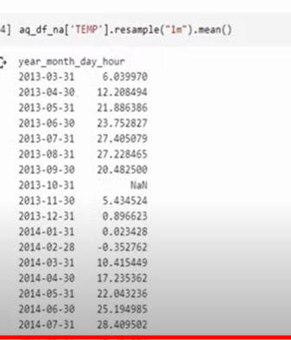

1m= one month

Aggregation = mean



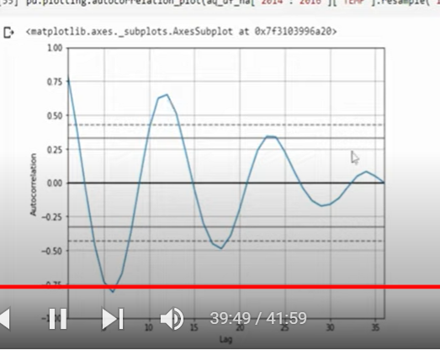

Every 12 months correlation

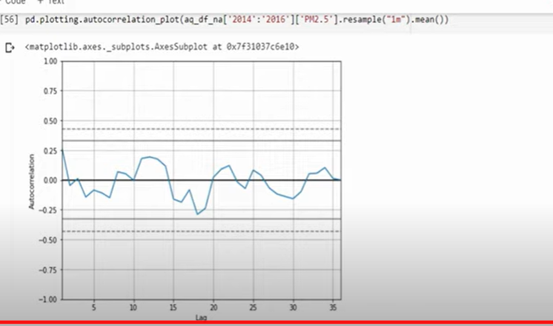

For pm the strength

Missing information

We cant drop data as we care order of data

Not good to replace mean, median (time series has seasonality or trend)

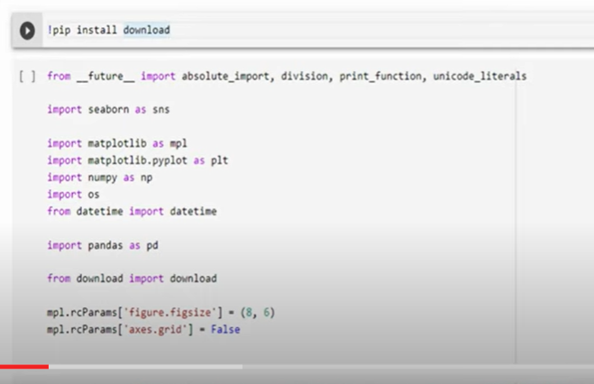

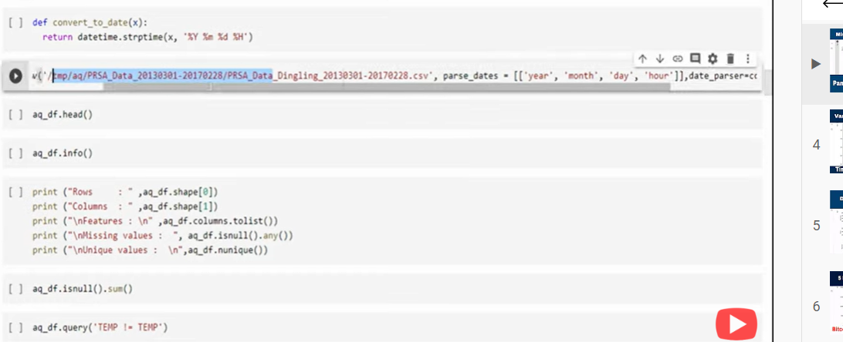

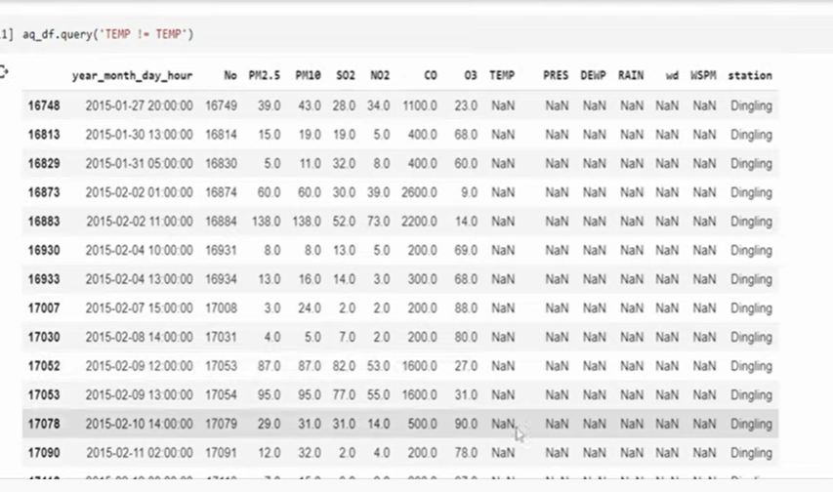

To get nan

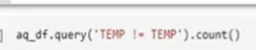

Above shows how many columns null when temp is null

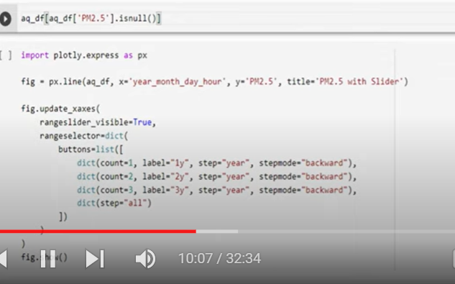

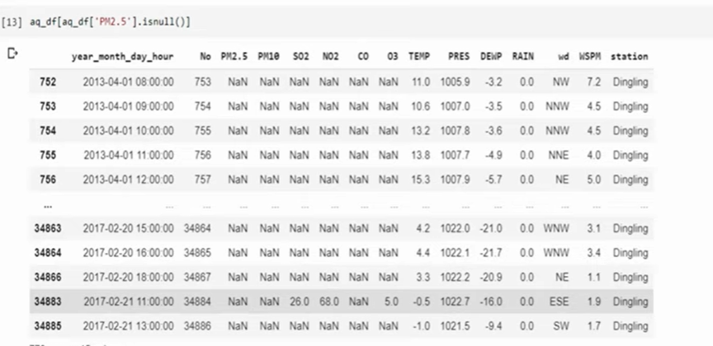

How missing values in grapgh

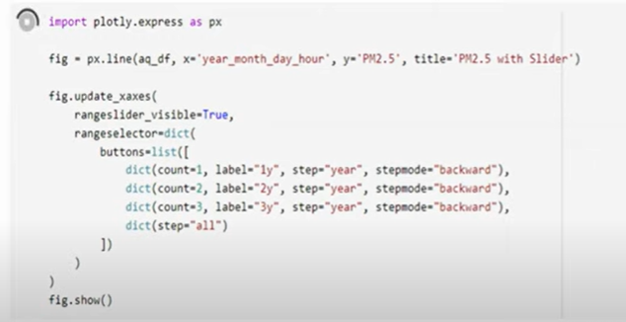

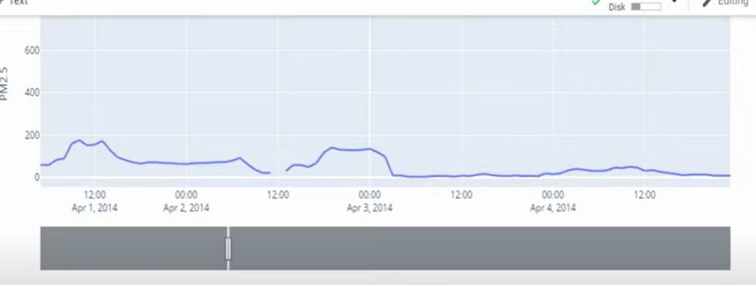

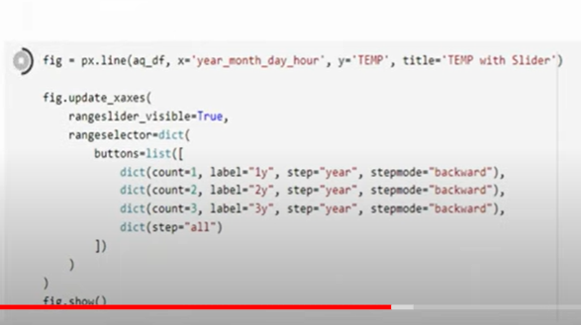

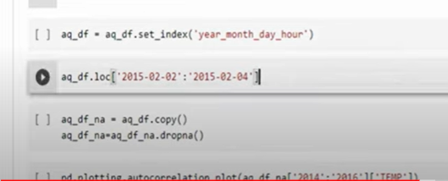

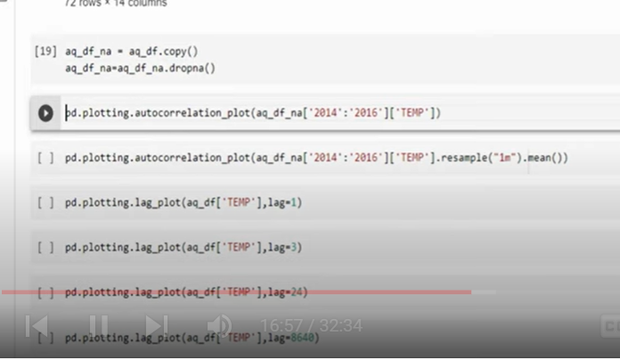

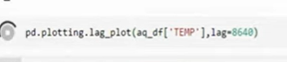

I can impute previous data

Or forward data

Avg of last 3 hours

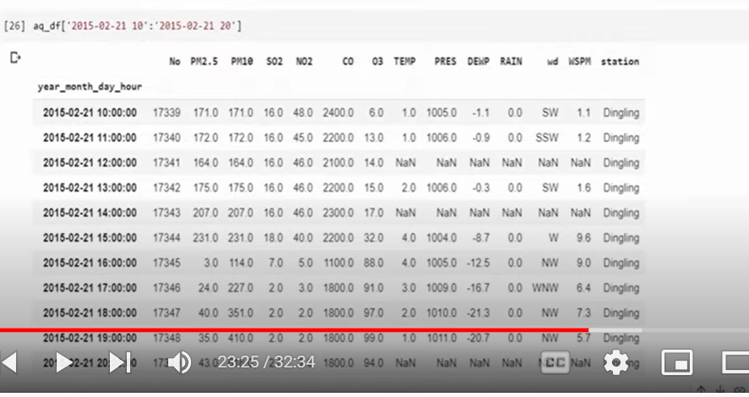

In temp 3 missing values

Only taking temp

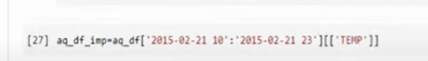

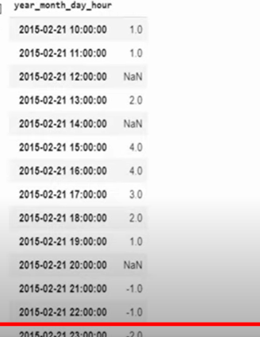

If good linearity with previous hr temp

Ffill- previous value to next value

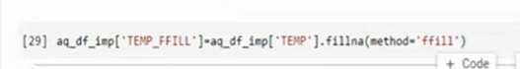

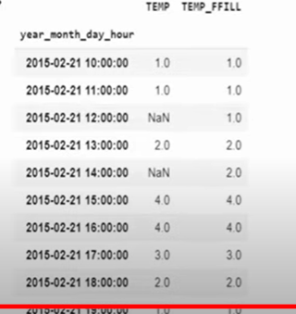

Generally we take ffill then bfill

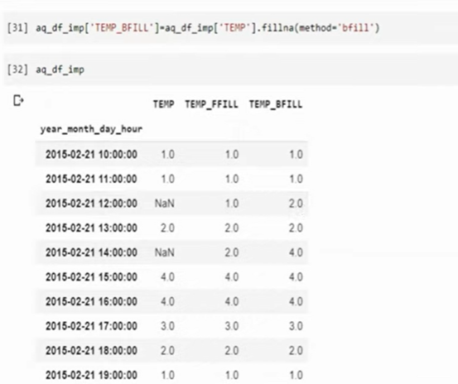



Window size=2 means previous two time lags

If previous value is not there then 1

Take mean

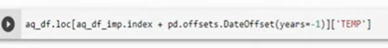

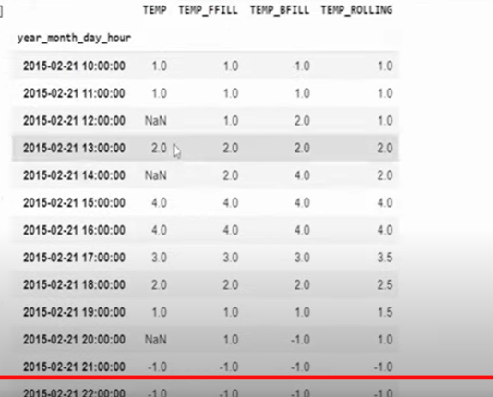

 Autocorrelation and Partial Autocorrelation

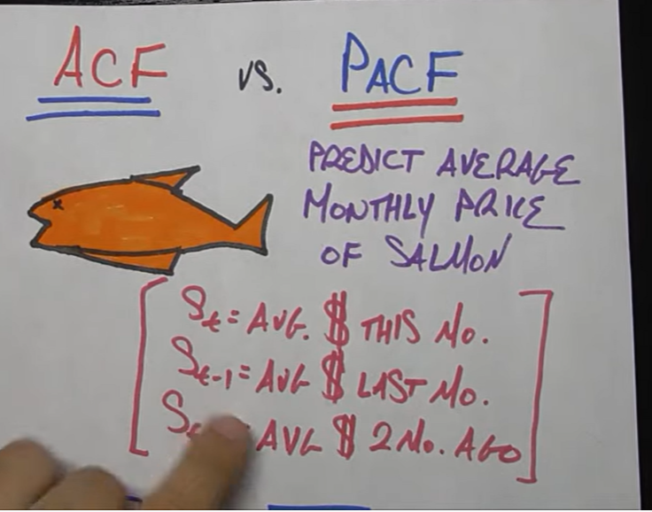

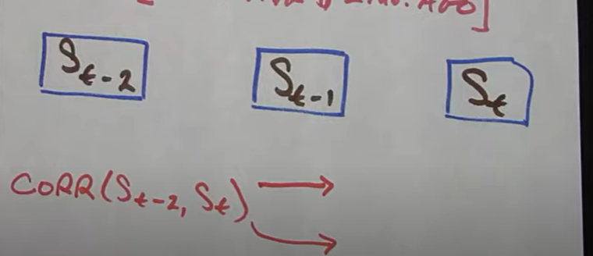

Direct and indirect effect: acf

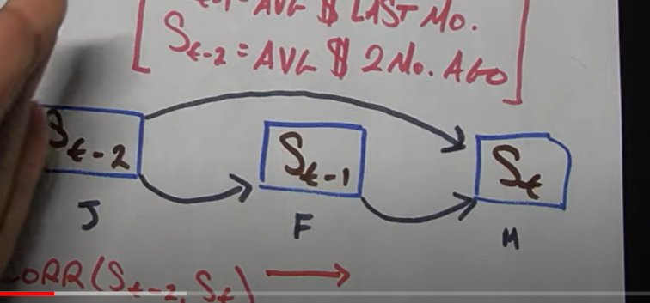

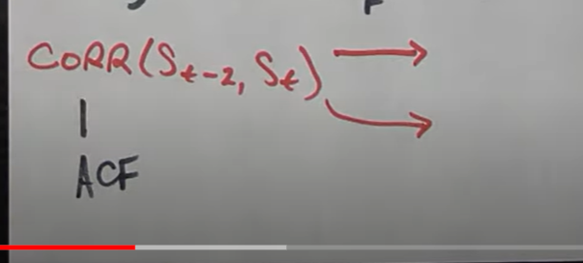

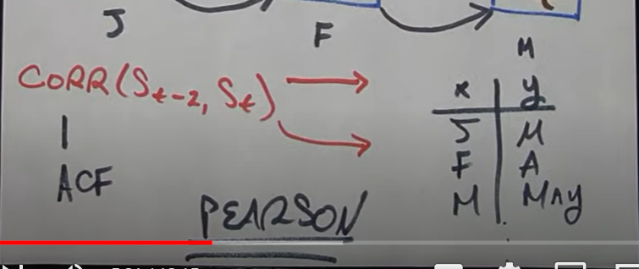

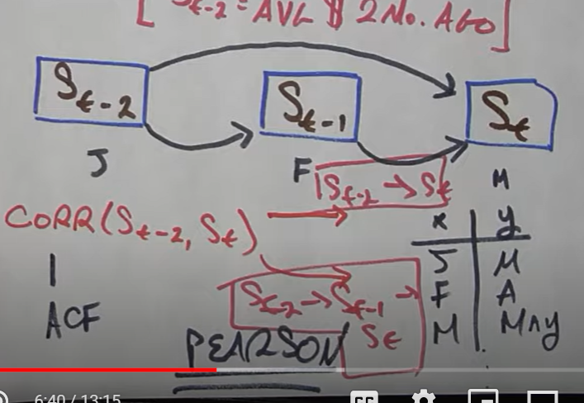

Pacf: direct only

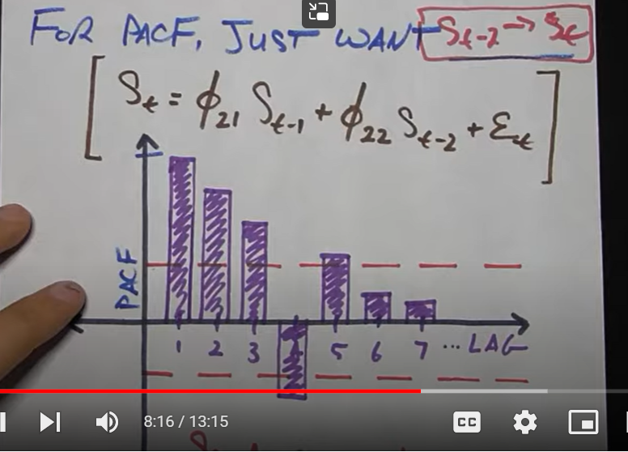

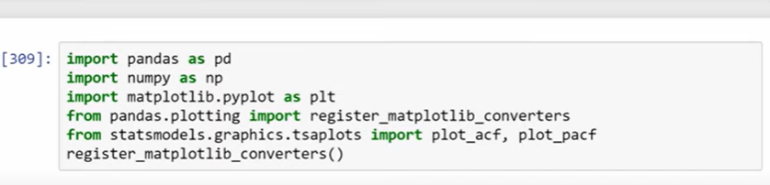

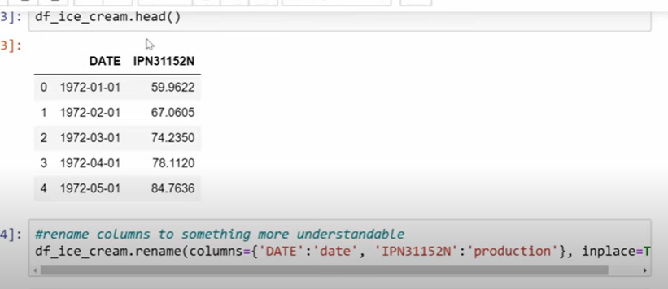

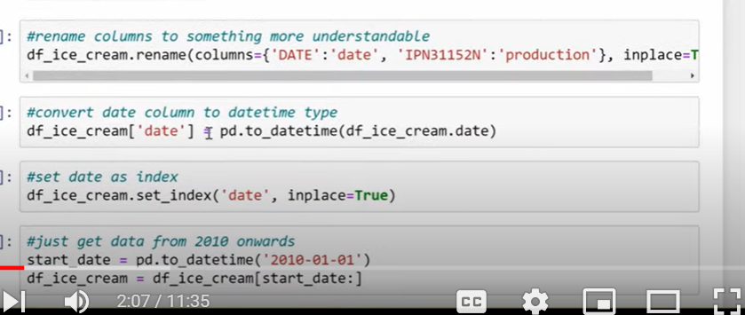

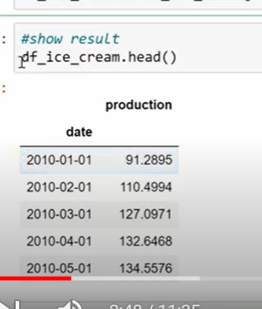

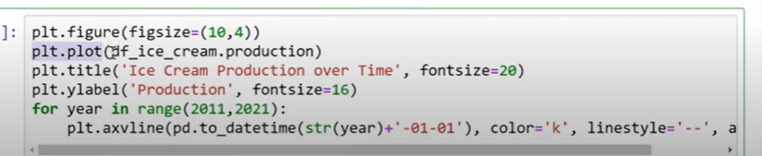

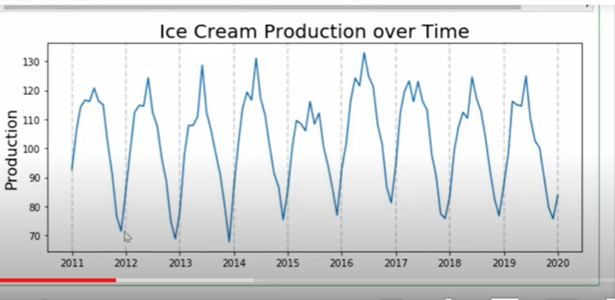

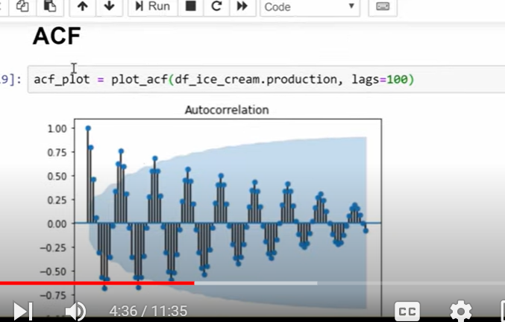

The correlation is decreasing as time passes by



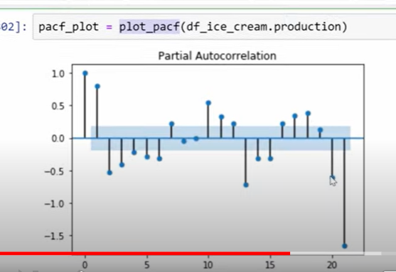

Strong lags at 1, 2,3, 13…

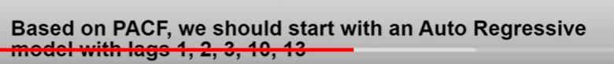

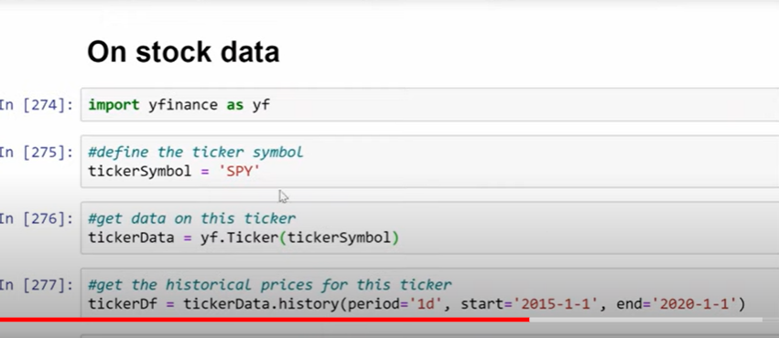

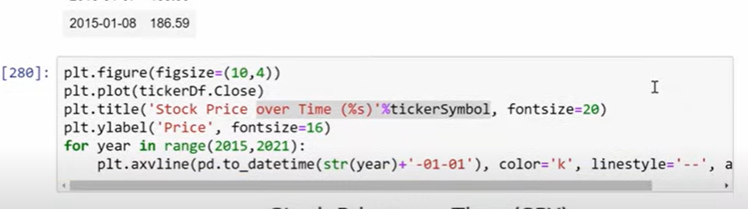

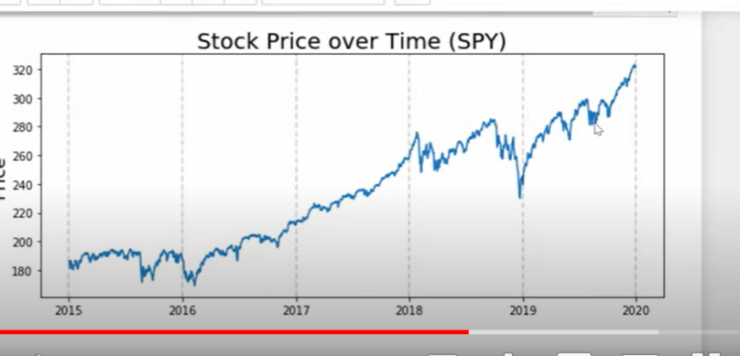

Graph is not stationary

To make it stationary

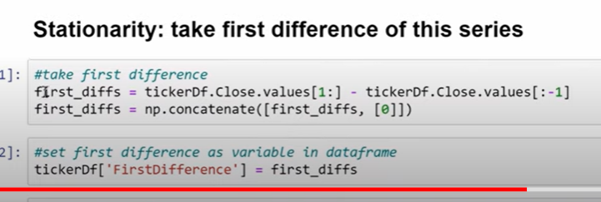

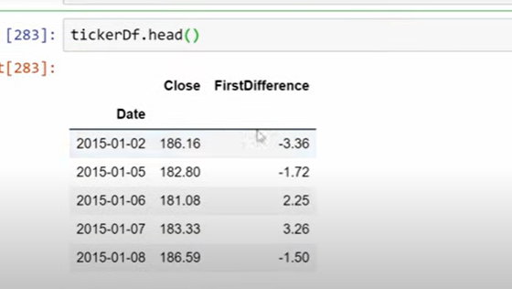

Plot that difference

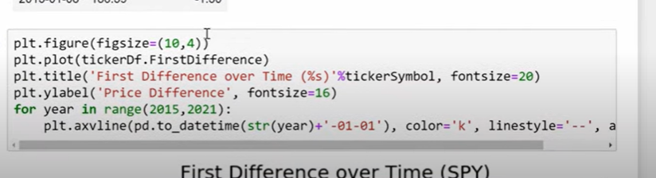

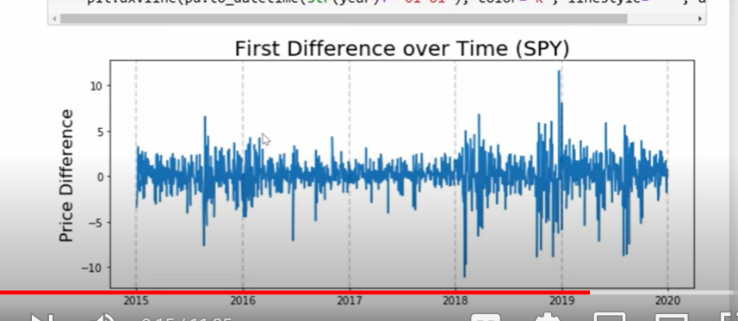

With this I can create acf and pacf plots

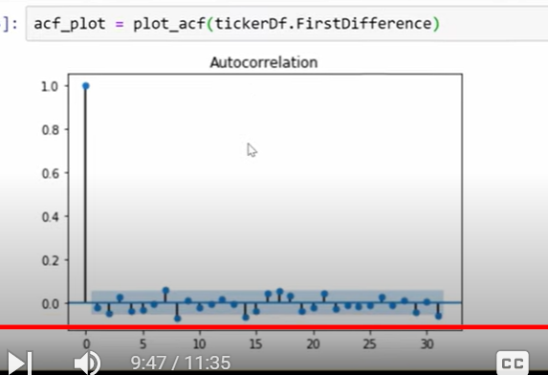

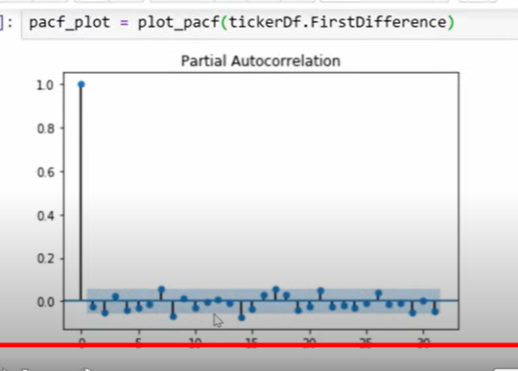

No strong evidence can be observed

Both graphs not tell us much

How to know time series stationary?

Mean constant

Sd constant

No seasonality

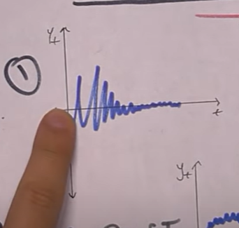

Above: mean constant

No seasonality

But sd is not constant

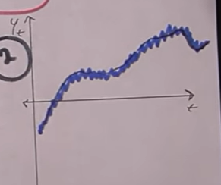

Sd is constsnt

No seasonality

Mean is changing

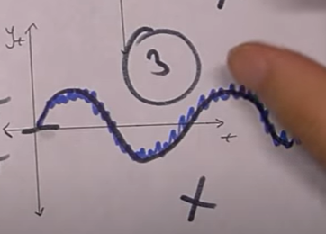

Above

Mean constant

Sd constant

There is seasonality

**How stationarity different from white noise**



**How to make time series stationary**

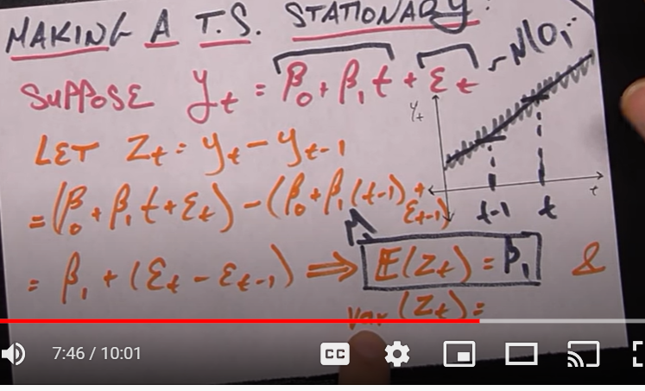

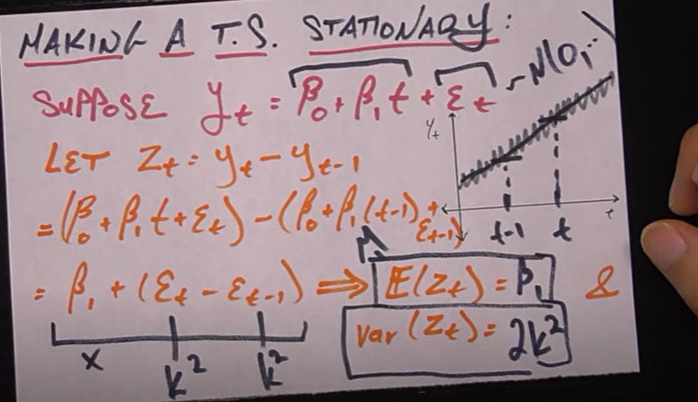

E= white noise

Zt is new time series

If 3 y values we have 2 zt values

UNIT ROOT;

If we have time series with unit root is not stationary we cant apply ar, ma or arma models

We need to do some transformations

Below might be stationary

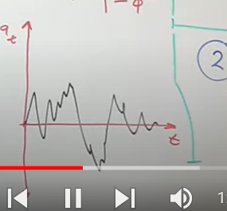

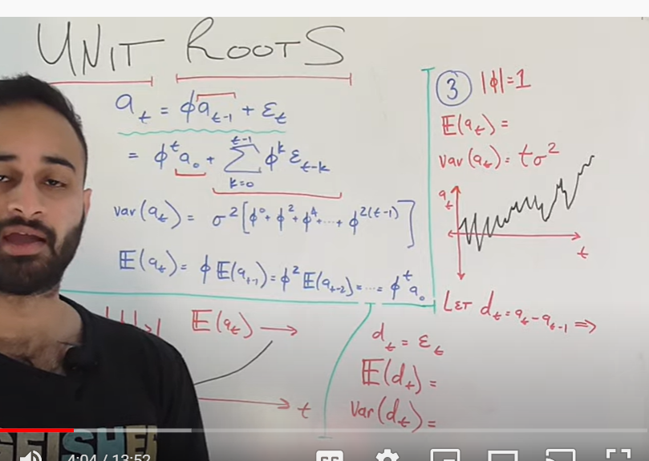

E(at) = expected value of time series

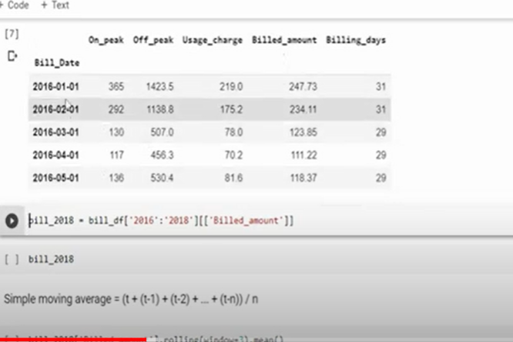

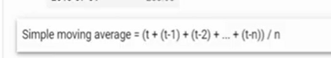

N= number of lags considered

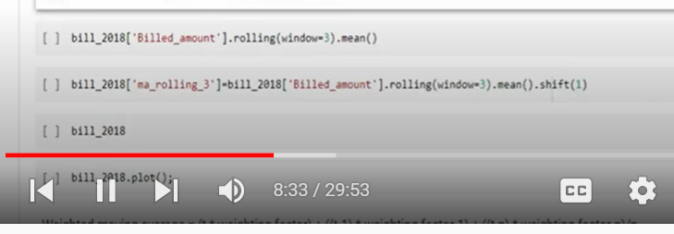

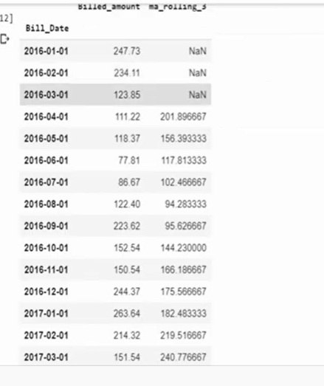

MA is good when data is not stationary

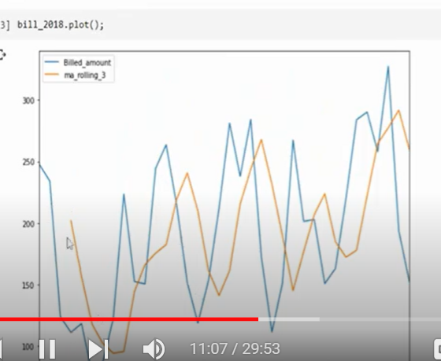

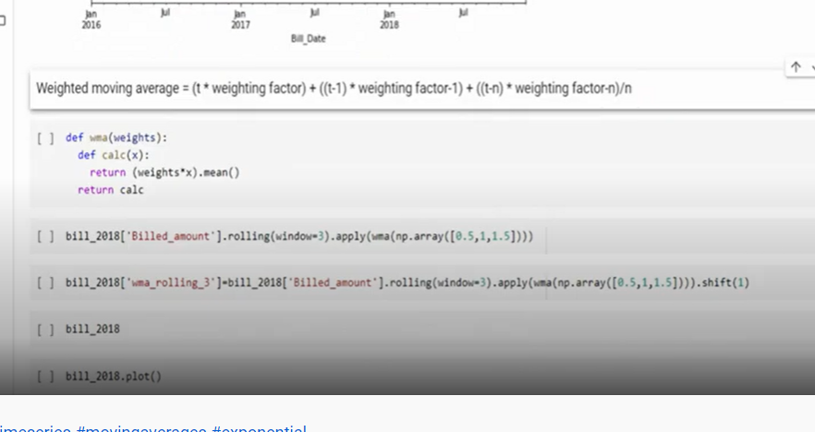

Weighted moving avg is where we give weightage to different datapoints on different lags

Latest = higher

Previour =lower weightage

Or reverse may be

Ex: frequency of visiting customers to store

Giving high weightage to recent data – to know probability of next visit

Weighted m.a can estimate trends sooner than MA

But there is complexity we need to assign weights manually

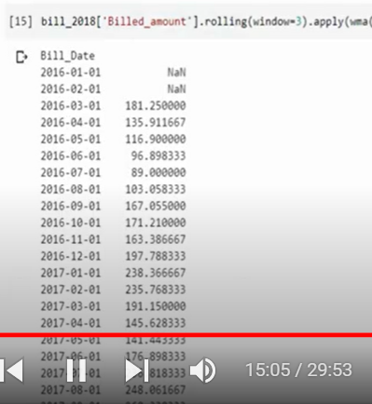

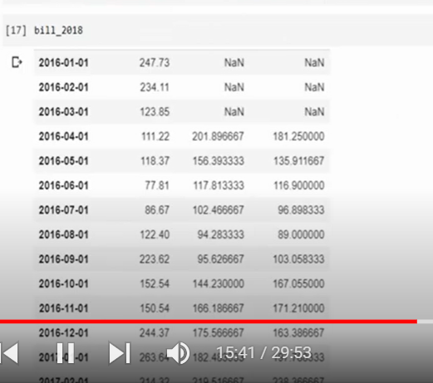

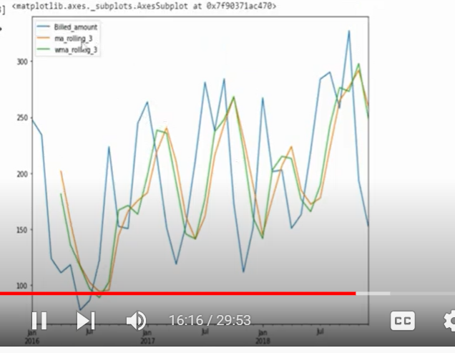

Green is better as it moves closer to blue line so error will be less

**Exponential moving avg**: similar to WMA

It calculate t-1 and calculate EMA

Instead of t-1 next time it takes EMA

It takes weights internally by avg it

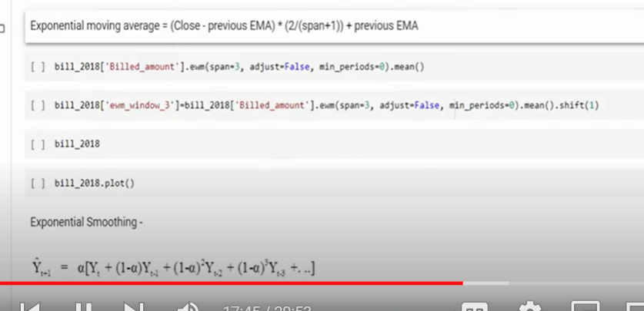

Span = duration of avg

An exponential moving average (EMA) is a type of [moving average](https://www.investopedia.com/terms/m/movingaverage.asp) (MA) that places a greater weight and significance on the most recent data points. The exponential moving average is also referred to as the exponentially [weighted](https://www.investopedia.com/terms/w/weighted.asp) moving average. An exponentially weighted moving average reacts more significantly to recent price changes than a simple moving average [simple moving average](https://www.investopedia.com/terms/s/sma.asp) (SMA), which applies an equal weight to all observations in the period.

KEY TAKEAWAYS

* The EMA is a moving average that places a greater weight and significance on the most recent data points.
* Like all moving averages, this technical indicator is used to produce buy and sell signals based on crossovers and divergences from the historical average.
* Traders often use several different EMA lengths, such as 10-day, 50-day, and 200-day moving averages.

0 seconds of 2 minutes, 3 secondsVolume 75%

2:03

**Simple Vs. Exponential Moving Averages**

Formula for Exponential Moving Average (EMA)

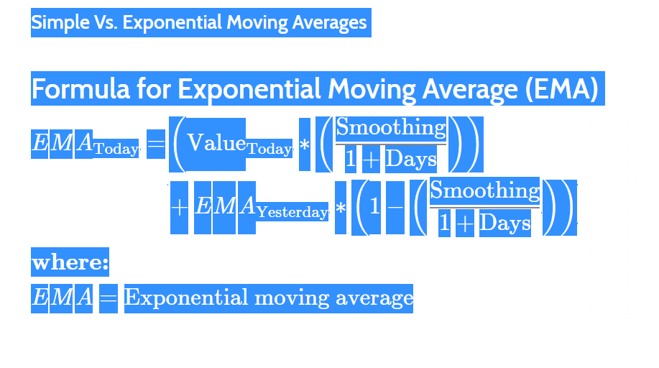

While there are many possible choices for the smoothing factor, the most common choice is:

* Smoothing = 2

That gives the most recent observation more weight. If the smoothing factor is increased, more recent observations have more influence on the EMA.

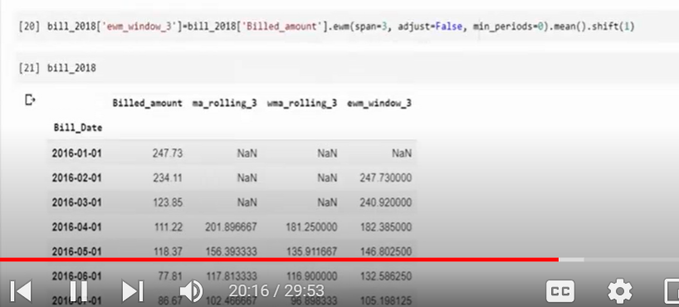

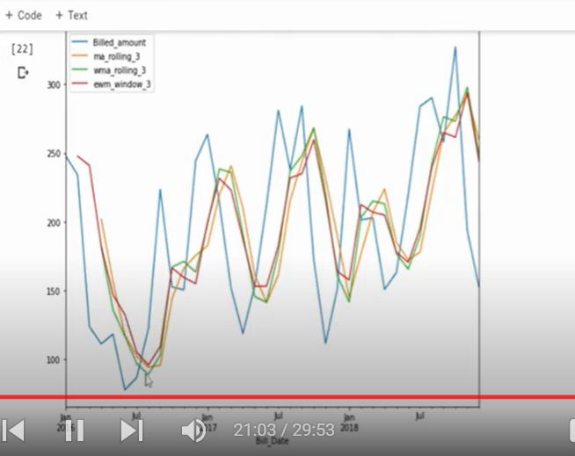

Exponential smoothening

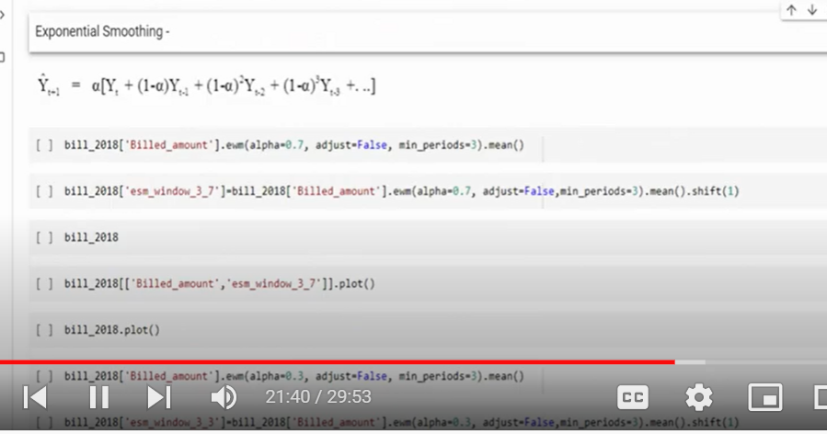

Exponential smoothing avg need additional value called alpha

Contrls the weight= alpha

Alpha=0 to 1

Hight alpha= giving much weightage to recent once

Less alpha means giving imp to historical data

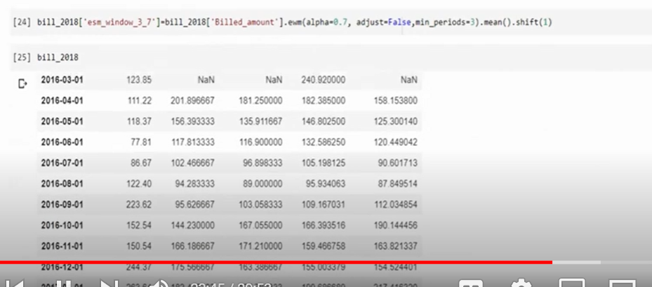

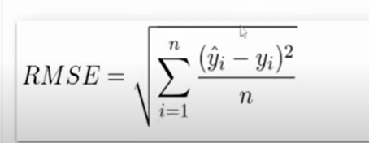

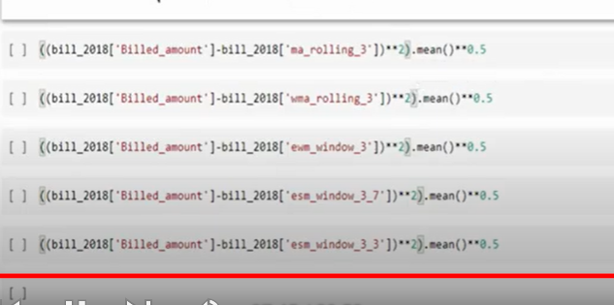

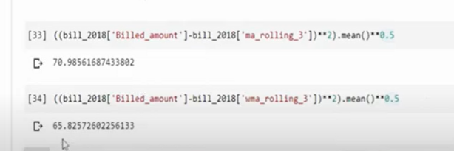

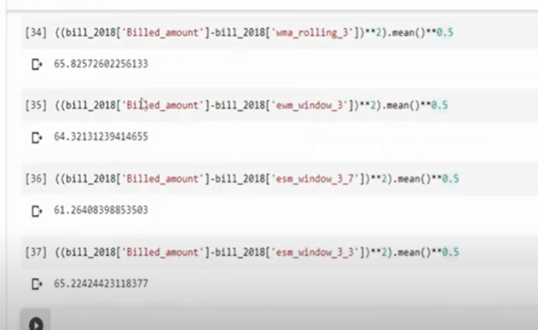

Less rmse better the model

Time series decomposition and analysis Using Python

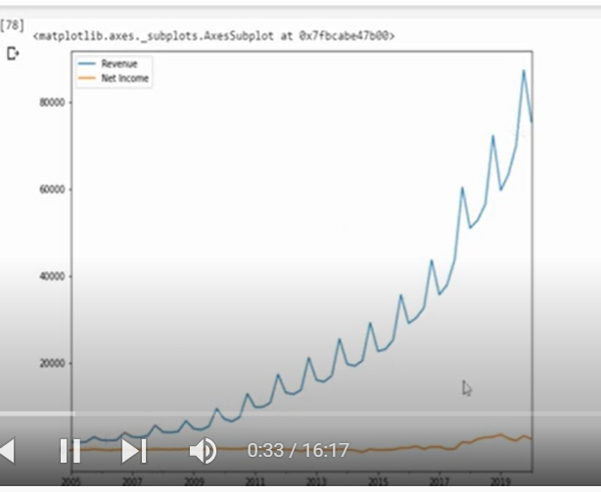

Blue= revenue

Positive trend

Seasonality is there

Seasonality: repeated and fixed in time periods

Cyclic: repeated but non periodic

**Time series decomposition**:

Statistical techniques that decomposes trends, noise, seasonality

When we remove all components the balance is called residual

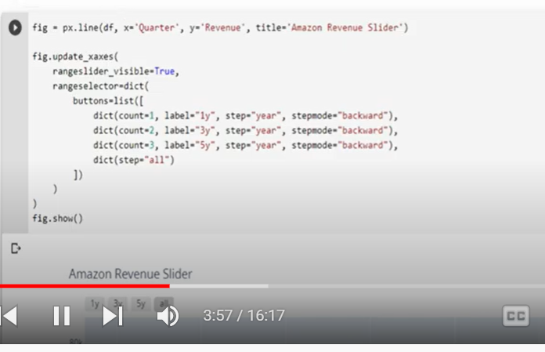

Slider

Why time series should be stationary?

**Why Time Series has to be STATIONARY ???**

This question choked me up for a long time when I had my first introduction to Time Series. I searched it all over, even took help from fellow kagglers but in vain. Recently, I got a great explanation.



courtesy: <https://thenewstack.io/time-series-data-care/>

**Dependent & Independent data**

First of all let’s clear this. Independent data can be any collection of samples independent of each other. Like Titanic, Household regression & so on.

Dependent data, as you would have guessed, samples dependent on each other. Like in Time Series. Here each sample is dependent on other samples present in the data

We must understand a thing, Independence cannot give us an idea of any sort of magnitude or pattern to follow up for prediction

Example-If two numbers are equal, we know their magnitudes are equal but if they are unequal, we don’t have any relation between their magnitudes. Like one can be double of other,1/2th of the other or even imaginary number. But the catch is WE DON’T KNOW the reason behind the inequality!

but for dependency, we can have some idea if we know at least one value. But we have got a problem, dependency can still take many forms. For Example-

Y=a+bX

Y=a+bX²

Y=a+bX³

here Y is dependent on X but each time the dependency takes a different form. But if we say Y is independent of X it can take any form.

Stationarity is just that form/model out of all the dependency models we use to find the relation between the samples in a time series & hence we try to bring our time series in stationary form.

**Stationarity & Non-Stationary data**

Like in the case of dependence & independence, the same goes for stationarity & non-stationarity. Like for stationarity we know we need constant mean, std & autocorrelation but for non-stationarity, we don’t know anything!! Non-stationarity, as discussed for independent data, can take any form. No fixed norms are present which can model non-stationary data like there exists ARIMA, AR, MA or any other model for stationary data.

The mean can be double, triple of the previous observations can be 0. The same goes for std & autocorrelation, hence it cannot be modeled & that’s why we convert non-stationary data to stationary first so as we know something about the features of this time series & hence can & apply our different models that I will be explaining in my next article!!!

**Common Terminologies to know**

**1) Rolling/Moving/Running-**

It refers to performing any operation (like sum, average, standard deviation) using a ***sliding window*** over the entire data.

**Example —**If the given data is [1, 2, 3, 4, 5, 6, 7] & window defined is 3, then rolling average would be [NaN, NaN, 2, 3, 4, 5, 6]. The first 2 values aren’t cannot complete a window & hence the NaN value.

**2) Lagged Features -**

It is generally a feature engineering technique where new features are generated by ***shifting*** given data by *t-1*, *t-2*, *t-3*, etc.

**3) AutoCovariance -**

It refers to the Covariance of a given data with the lagged versions of itself.

**Example —**If we need to calculate AutoCovariance with the 5th lagged version, we need to shift our data by 5 places i.e. if the starting date for your series is 6th June, then a lag by five will have starting date 1st June corresponding to 6th date of unlagged version.

**4) Partial AutoCovariance -**

It refers to Covariance of given data with lagged versions of itself BUT after *removing covariance due to other smaller lags*.

**Example —**For calculating the Partial AutoCorrelation between the data & its Kᵗʰ lagged version, we eliminate the covariance effect due to *K+1*ᵗʰ, *K+2*ᵗʰ lags of the version on *K*ᵗʰ lag.

**5) Stationarity of Time Series -**

A time series is stationary if the ***mean, standard deviation & autocovariance remain constant.*** This means that *there shouldn’t be frequent fluctuation when* you use a rolling window for calculating the mean/ standard deviation / autocovariance.

**6) Trends -**

A gradual increase/decrease in data values as time passes starting from any point in time.

**Example —**A sudden increase in TRP of a channel due to some celebrity episodes.

**7) Seasonality -**

When a trend repeats itself periodically from time to time.

**Example —**High sales in the month of May every year can be taken as seasonality.

**8) Resampling -**

Converting your data to either higher frequency or lower frequency.

**Example —**Converting monthly data to day-wise data or day-wise data to monthly data.

**9) White Noise -**

It refers to data with 0 mean but random/independent in nature and has 0 correlation with other values in the series. If your time series is White Noise, you can’t make predictions.

**10) Stochastic process -**

A process that yields different results on applying the same equation i.e. a random process.

**11) Random Walk -**

This process aims at forecasting the future values using the equation.

Y(t)=Y(t-1) + e

where *e* is white noise term which is random for every prediction & hence random walk.

**12) Random walk with Drift -**

It is similar to a random walk with a slight change. Here the values are predicted using the equation

Y(t)=Y(t-1) + D +e

where *D* is the Drift constant, *e* is white noise term.

**13) Additive models -**

These are the models that consider that the data has been generated using the following equation:

Data = Seasonality + Trend + Residuals

where residuals are the values left when the trend & seasonality have been removed from the any time series

**14) Multiplicative models -**

These models consider that data has been generated using the following equation:

Data = Seasonality X Trend X Residuals

This much might be enough for the day. Do follow up for my next article on creating your first Time Series solution using ARIMA.

Below you can check out different models for univariate time series forecasting

More on Time Series below:

Stationarity test: kpss and adf

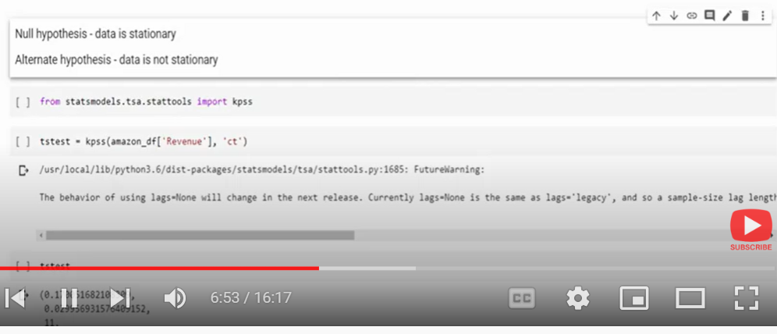

Decompose

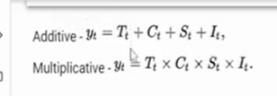

If data is not trend stationary = multiplicative

If its trend stationary = additive

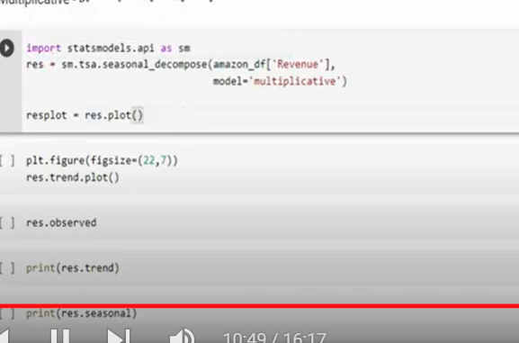

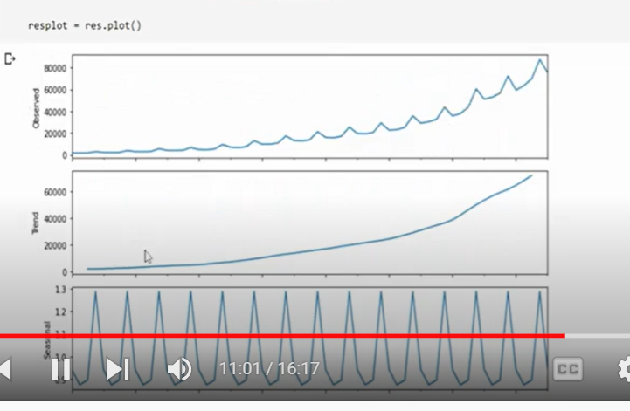

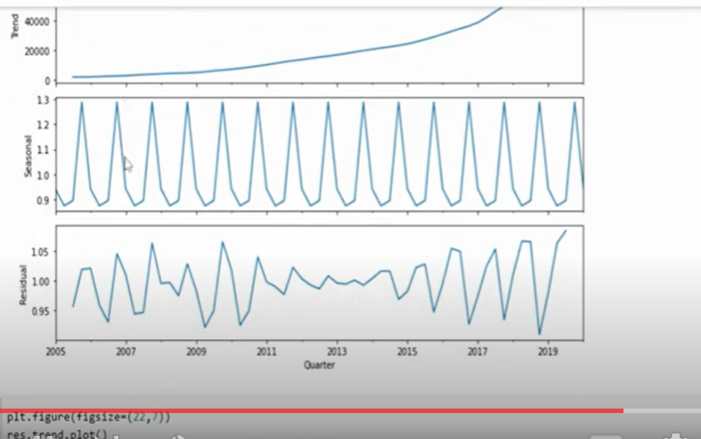

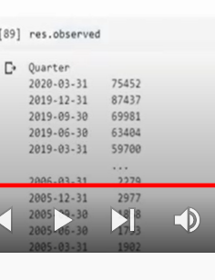

Abserved value=actual value

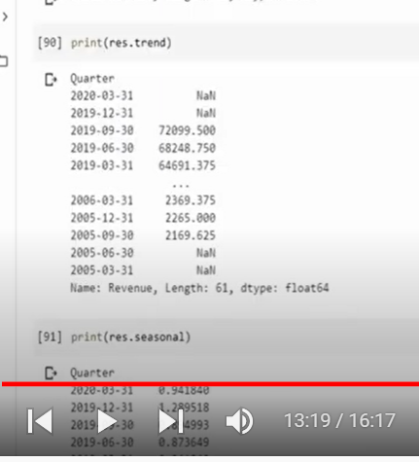

Absorved value= trend*seasonal*residual

Detrended value: for multiplicative

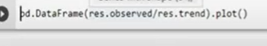

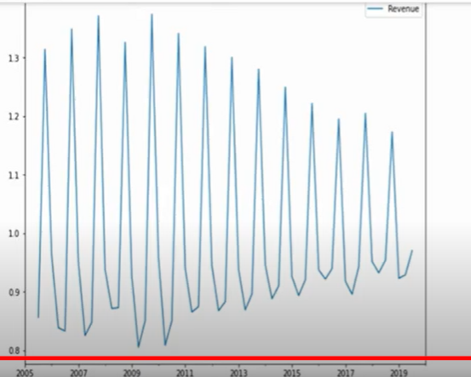

Detrended in additive:

Observed- trend

With removing trend we can use it for autoregression

Python Functions for Time Series Modeling and Analysis

Import request :

To use real time data

We should use API

Python functions:

1. Resampling:

We can change frequency

Monthly

Quarterly

Yearly

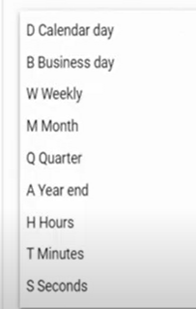

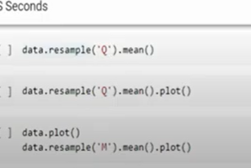

Resampling analyses better without loosing essence of data

Second function:

Detrending data : diff()

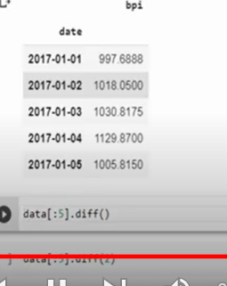

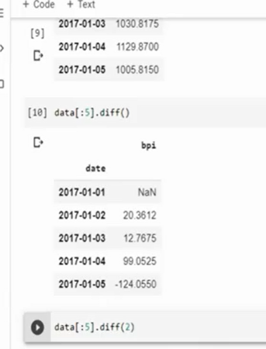

If weekly trend

Then difference is bussinessdays

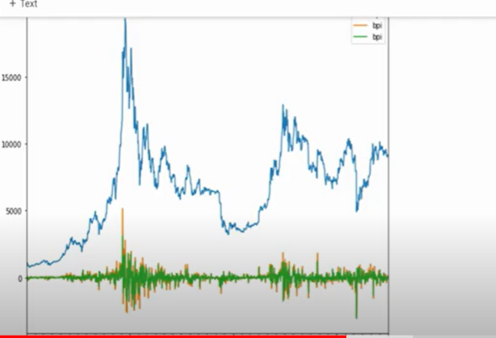

Shift()

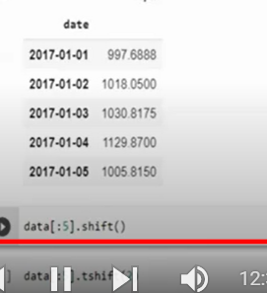

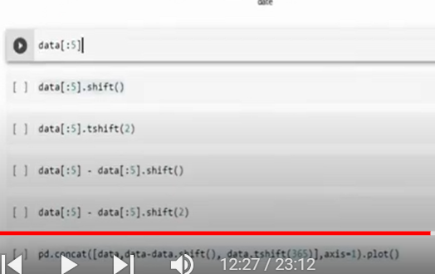

There is similarity between diff and shift

Shift the index values

Default=1

Tshift= timeshift

Timeshift(2)

Shift 2 periods

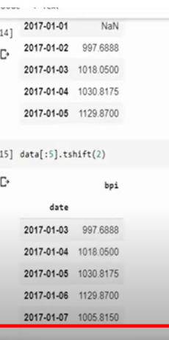

Removed 1st and 2nd

Example corona phase removed inorder to estimate sales as sales during corona was under the influence of effects of corona

Only shift()

Difference of previous timestamp

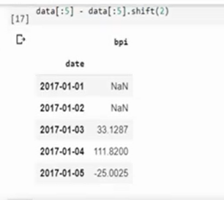

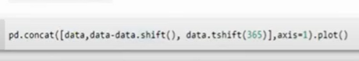

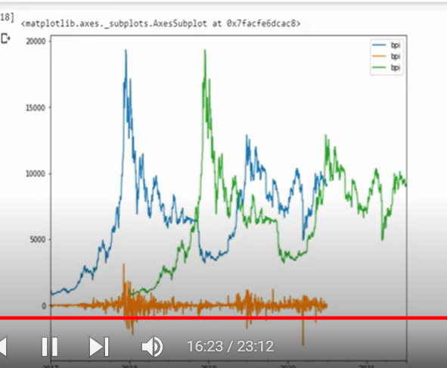

Blue = original

Green = shift by one year

Shift= detrending

Next function=

Rolling window()

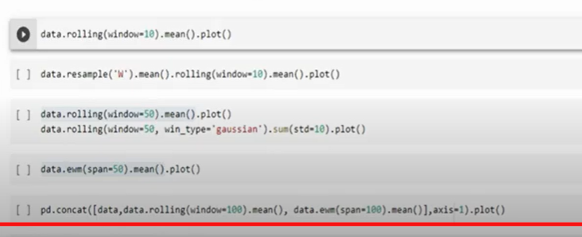

How many times he has visited in last 10 days

10 days moving avg

Smoothen data

Also we can select window types

**Grouping function:**

**Yearend**

**Month by month**

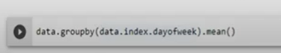

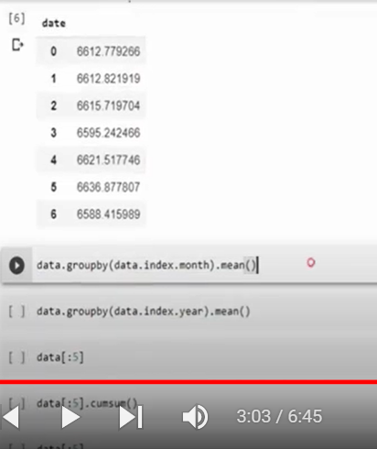

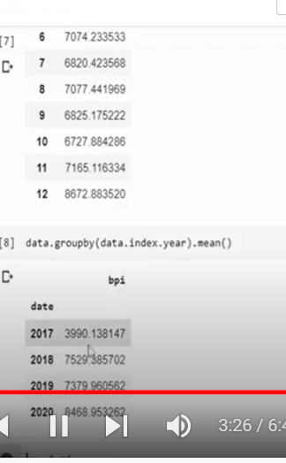

**Cumulative sum**

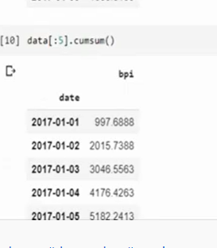

**Taking 5 rows and do cumulative sum**

**P**ercentage change:

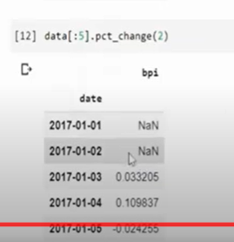

Pct_change(timelag)

One day=2

Weak= 7

Month 30

Expanding ():

Similar to cumilative’

Cumulative only for sum

Expanding for mean , sum ..

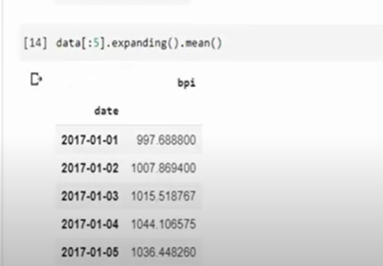

Time Series Non Stationary Statistical Test - KPSS and ADF

Mean, variance and auto correlation don’t change over time

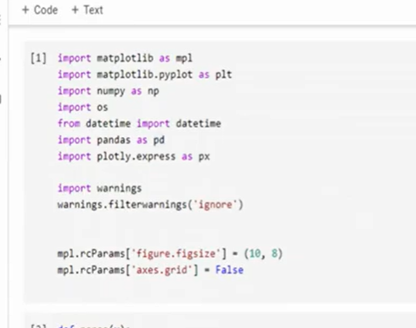

If ur time series is not stationary(trend) must go for arima

Differentiating : present time log must be differentiating from previous

If ur time series has seasonality must go for SARIMA

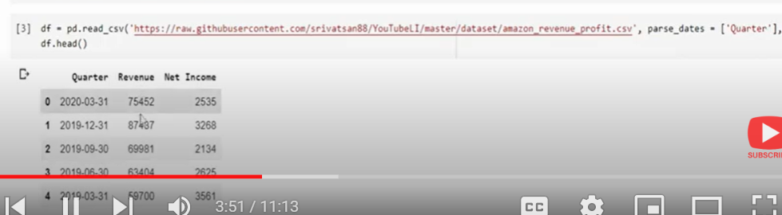

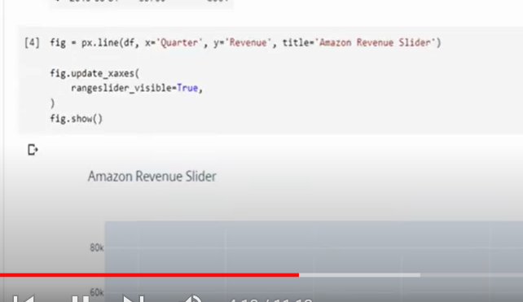

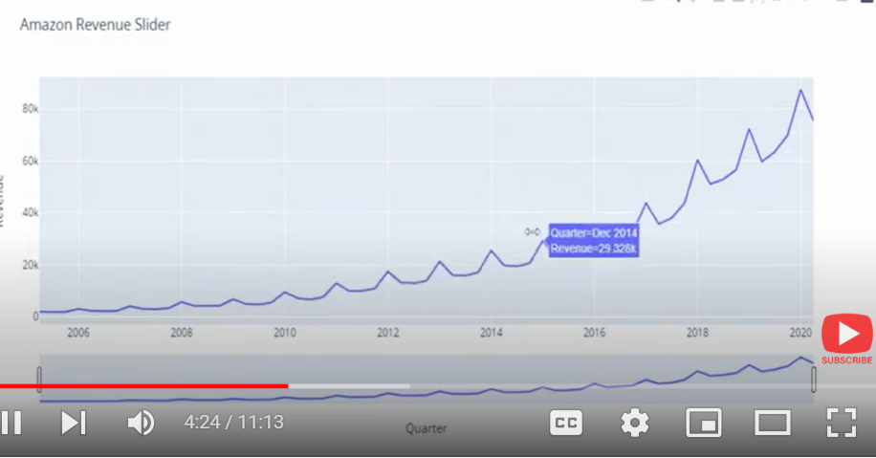

Trend is there

Better to run statistical tests

KPSS test

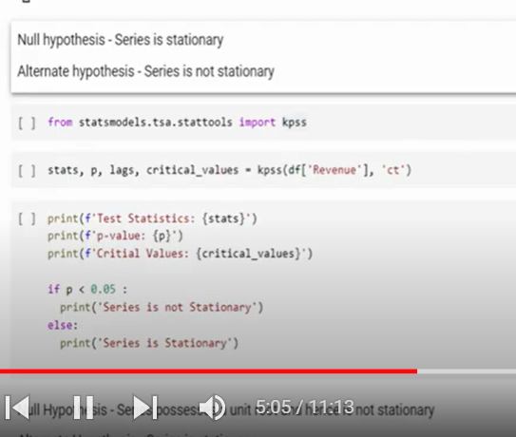

Ct= mean trend component

C= stationary

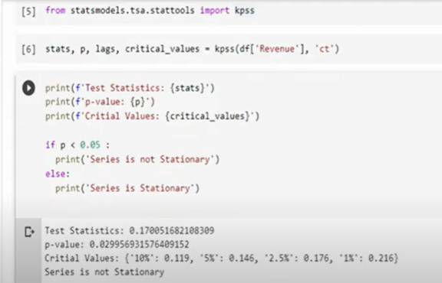

ADF test

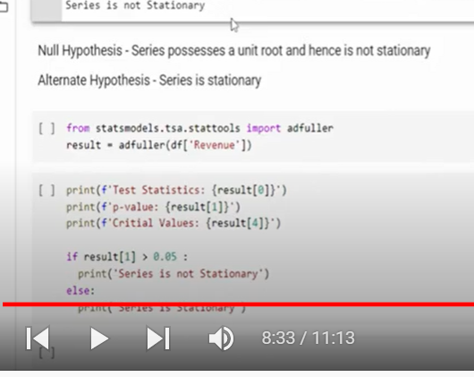

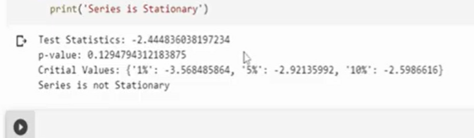

End to End Time Series Modeling using Auto ARIMA

[End to End Time Series Modeling using Auto ARIMA - YouTube](https://www.youtube.com/watch?v=MngVV_4l9Po&list=PL3N9eeOlCrP5cK0QRQxeJd6GrQvhAtpBK&index=9)

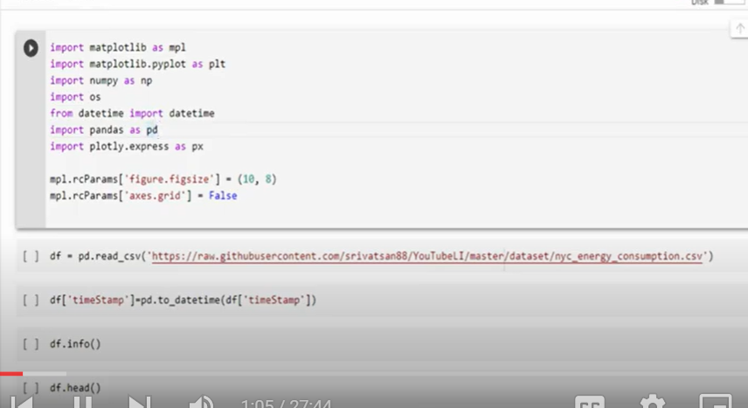

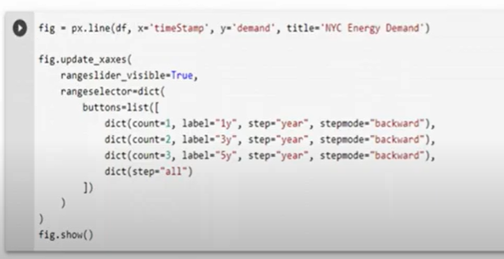

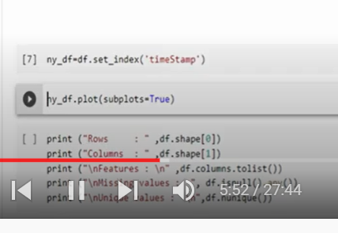

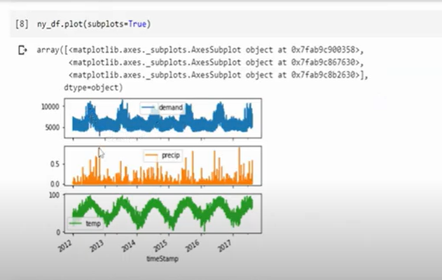

Temp increases and demand increases

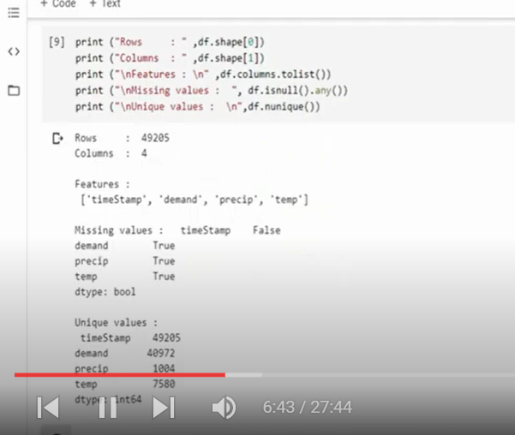

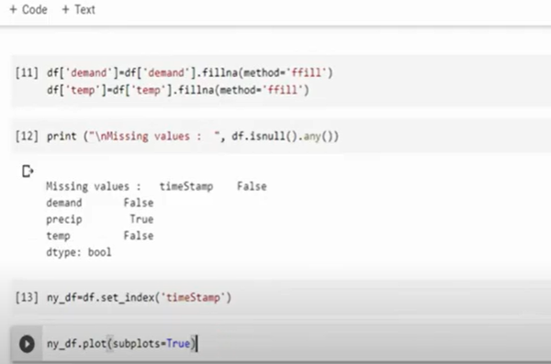

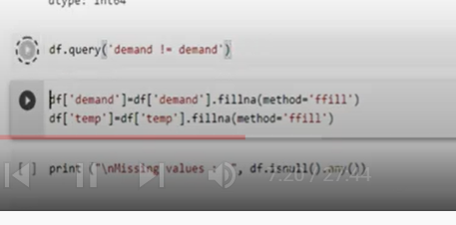



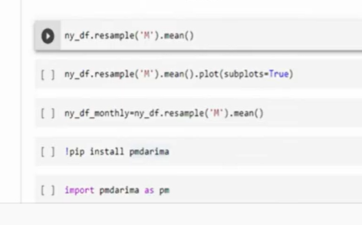

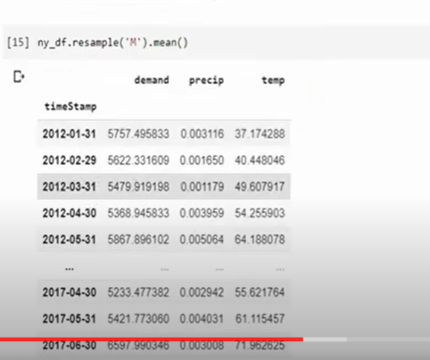

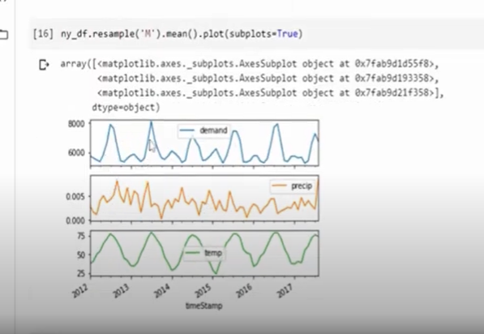

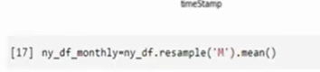

Resampling and assigning to diff dataframe

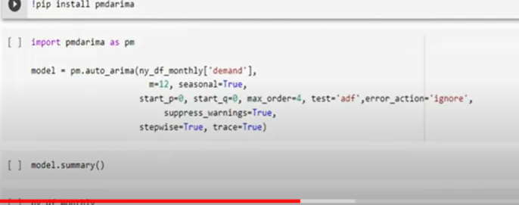

Auto arima: grid search kind

It takes various parameters

Stepwise= random

Go through multiple p,d,q parameters

Best models

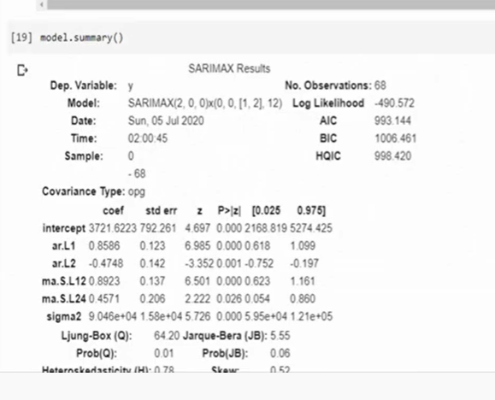

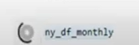

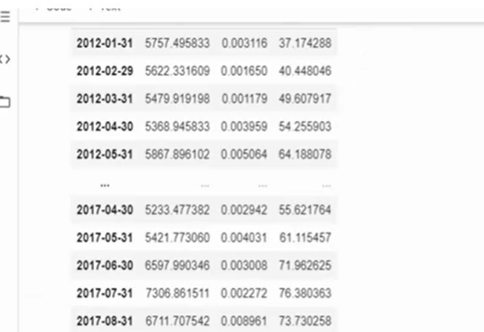

Train and test split

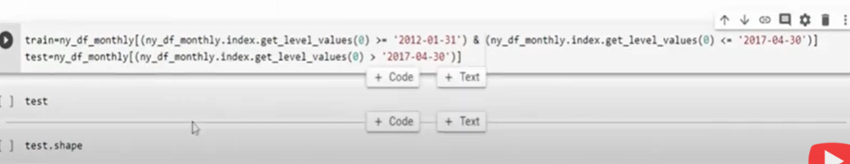

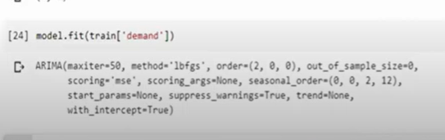

Predict:

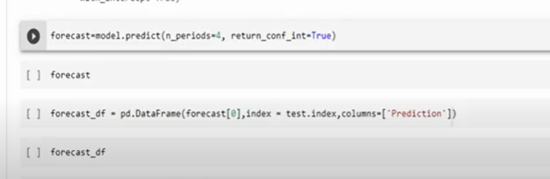

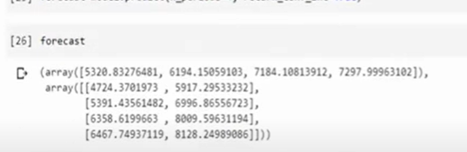

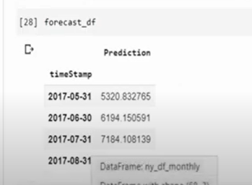

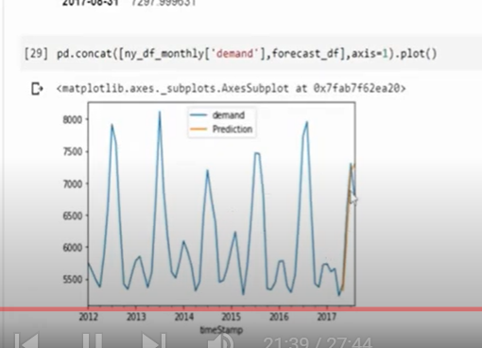

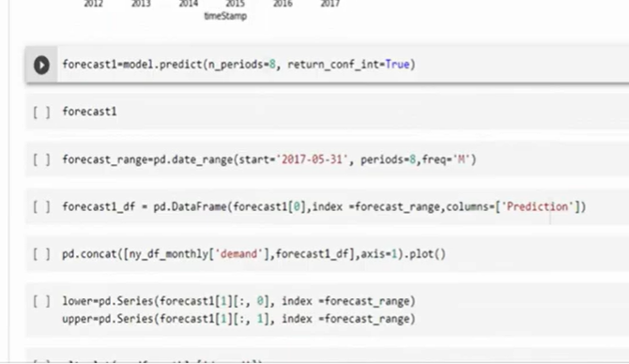

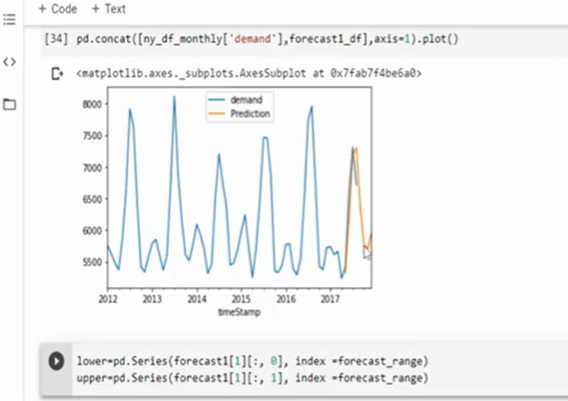

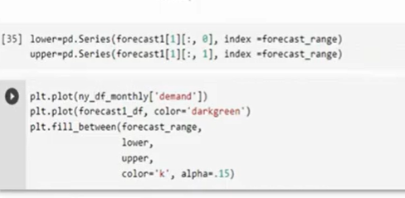

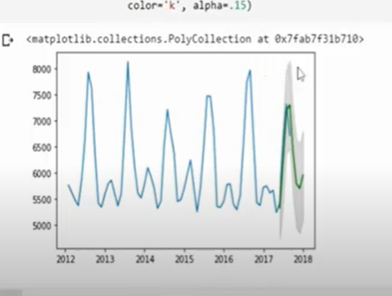

Green is actual value

Grey is upper and lower value

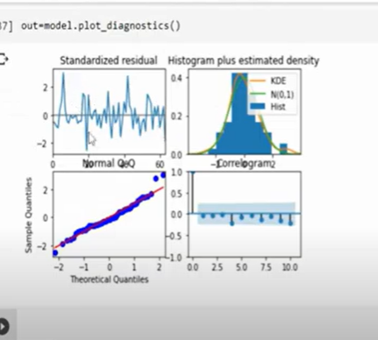

**Forecasting procedure**:

1. Choose a model

2. Split data into train and test sets

3. Fit model on the train set

4. Evaluate the model on the test set

5. Refit the model on the entire dataset and forecast future unknown data

**. Choose a model**

There is a wide range of models and forecasting algorithms available. Some of them include:

* **Average method**: The forecasts for all future values are equal to the mean of the historical data. [bad]
* **Naive method**: The forecasts are equal to the value of the last observation. [bad]
* **Seasonal Naive method:** The forecasts are equal to the last observed value from the same season of the year. [bad]
* **Drift method:** A variation of the naive method is to allow the forecasts to increase or decrease over time, where the amount of change over time (called the drift) is set to be the average change seen in the historical data. [bad]
* **Simple, Double and Triple Exponential Smoothing.** We talked in-depth about these methods in a [previous](https://towardsdatascience.com/time-series-analysis-with-theory-plots-and-code-part-2-c72b447da634)article. [only TES is decent]
* **ARIMA and friends** (ARMA, ARIMA, SARIMA, SARIMAX, VAR, VARMA). [decent]
* **Facebook’s Prophet**: An open-source library published by Facebook that is based on decomposable (trend+seasonality+holidays) models. [decent]
* **Machine Learning Algorithms**: From Gradient Boosting to LSTMs. [good?]
* **Average of the above**: Take the average of the forecasts by a ML algorithm and let’s say Simple Exponential Smoothing. [good]

**2. Split data into train and test**

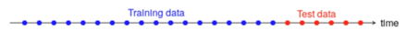

Train-test split.

* There is no default value, but about 20% of the total data for the test is a good value. Other great possible values are, depending on the problem, a week, a month, etc.
* The test set should ideally be at least **as large as the maximum forecast horizon** required.
* The longer the horizon, the less accurate the prediction.

Import libraries.

Import data.

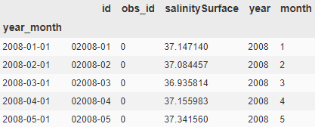

First five rows.

We have loaded our data which consist of monthly sea surface salinity values for 10 years.

Train-test split.

We keep 8 years (12x8) as the train set and the rest 2 years as the test set.

**3. Fit the model on the training set**

Let’s fit 3 models. Simple Exponential Smoothing, Double Exponential Smoothing, and Triple Exponential Smoothing.

Fitting 3 models.

**4. Evaluate the model on the test set**

It’s super-easy to forecast using *.forecast()*

Forecast for the next 24 months.

Visualize forecasts.

Plot forecasts along with train and test data.

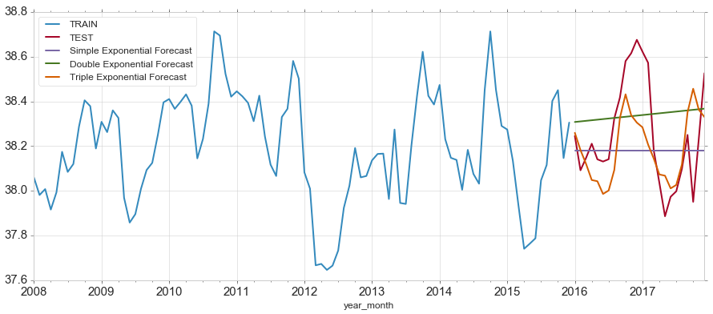

Visualization of the forecasts.

We can clearly see the Triple Exponential Smoothing outperforms the other two. We can measure the performances with **Root Mean Square Error**.

RMSE of predictions.

This outputs:

Simple Exponential Smoothing RMSE: 0.2423  
Double Exponential Smoothing RMSE: 0.2491  
Triple Exponential Smoothing RMSE: 0.2033

*Tip: Having RMSE less than std is a good indicator of our forecasting model.*

This outputs:

0.236641

So Triple Exponential Smoothing with RMSE 0.2033<0.2366 is an acceptable model.

**5. Refit the model on the entire data set and forecast future unknown data**

Re-train on all data and predict the next 12 unknown months.

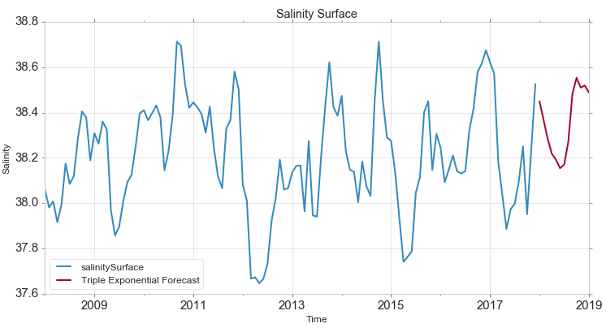

Predicting the future.

Now you know how to process a time series forecasting task and make future predictions for your own data.

Thanks for reading, see you next time!

1. **Level** : Any time series will have a base line. To this base line we add different components to form a complete time series. This base line is known as **level**.
2. **Trend** : It defines whether, over a period, time series increases or decreases. That is, it has an upward (increasing) trend or downward (decreasing) trend. For eg. the above time series has an increasing **trend**.
3. **Seasonality :**It defines a pattern that repeats over a period. This pattern which repeats *periodically* is called as **seasonality**. In the above graph, we can clearly see the seasonality component present.
4. **Cyclicity** : Cyclicity is also a pattern in the time series data but it repeats *aperiodically*, meaning it doesn’t repeat after fixed intervals.
5. **Noise** : After we extract level, trend, seasonality/cyclicity, what is left is **noise**. Noise is a completely random fluctuation in the data.

We get the above components when we decompose the time series. There are mainly two types of time series decomposition, namely, **additive seasonal decomposition** and **multiplicative seasonal decomposition**.

Simple way to understand this is,when the individual components of the time series at hand add up to get the original time series, it is called additive seasonal decomposition. In case, the individual components need to be multiplied to get the time series data, then it is called multiplicative seasonal decomposition. The main reason to use one type of decomposition over the other is that the residue should not have any pattern. That is, it should just be some random fluctuation.

**Time Series Forecasting Python Implementation**

With the help of an example we will now see, how various forecasting techniques are implemented in python and their effectiveness.

Let’s first understand the meaning of evaluation metrics that we will use to evaluate these forecasting techniques.

**RMSE : R**oot **M**ean **S**quared **E**rror is the square root of Mean Squared Error (MSE). MSE is nothing but a representation of how forecasted values differ from actual or true ones. We take the square root in order to avoid the negative sign as errors can be positive or negative. It is represented by the following formula :

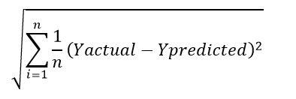

**MAPE : M**ean **A**bsolute **P**ercentage **E**rror is the measure of how accurate a forecast system is. It measures this accuracy as a percentage, and can be calculated as the average absolute percent error for each time period minus actual values divided by actual values. It is represented by the following formula :

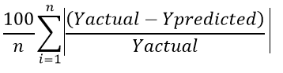

Where *Yactual* is the true value and *Ypredicted*is the predicted value at that particular time. *n* is the number of observations.

Both RMSE and MAPE should be as low as possible.

**So here is the problem statement** : Global Mart is an online super giant store that has worldwide operations. It takes orders and delivers across the globe and caters to 7 different geographical market segments — (Africa, APAC (Asia Pacific), Canada, EU (European Union), EMEA(Middle East), LATAM (Latin America), US (United States)). It deals with all the major product categories — Consumer, Corporate and Home Office. We need to **forecast the sales for the most consistently profitable market-segment.**

**Note**: The code and the graphs used in the article, are present in the python file whose link is given at the end of the article.

**Flow of Analysis :**

**1. Import the required libraries**  
**2. Read and understand the data**  
**3. Exploratory Data Analysis**  
**4. Data Preparation**  
**5. Time Series Decomposition**  
**6. Build and Evaluate Time Series Forecast**

1. **Import the required libraries**

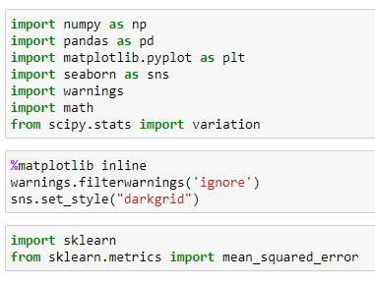

2. **Read and understand the data**

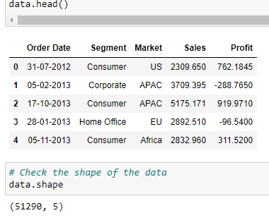

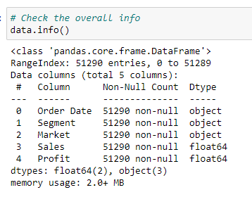

**Exploratory Data Analysis**

We do the outliers analysis of various attributes and find that there are indeed outliers present in the profit and sales columns.

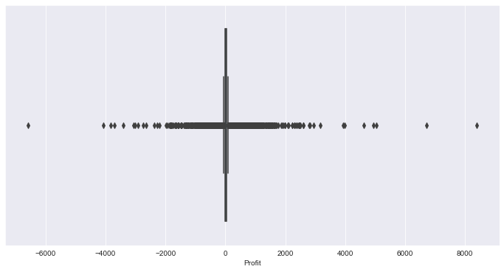

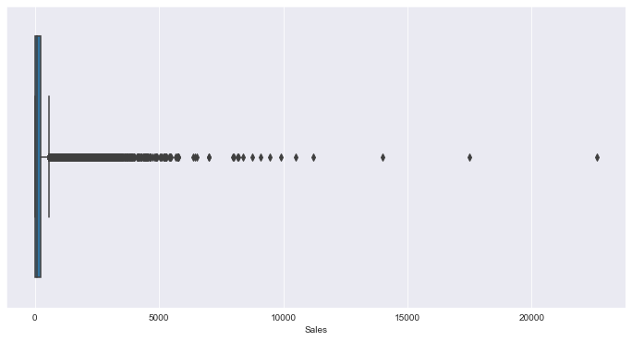

In the time series data, there are observations pertaining to all time stamps and so we cannot delete the outliers, as it results in loss of data and affects it’s continuity.

We performed univariate, bivariate and multivariate analyses and here are the graphs.

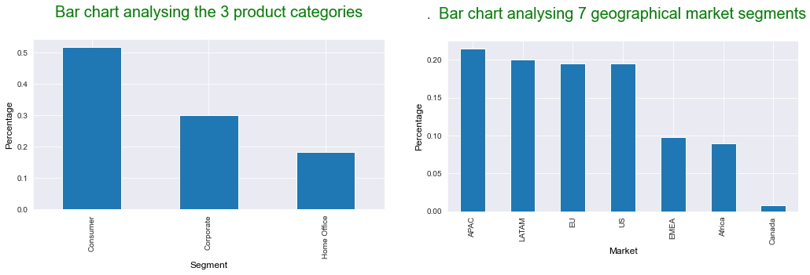

Univariate analysis

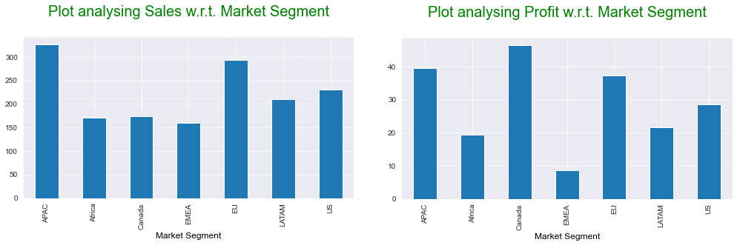

Bivariate analysis

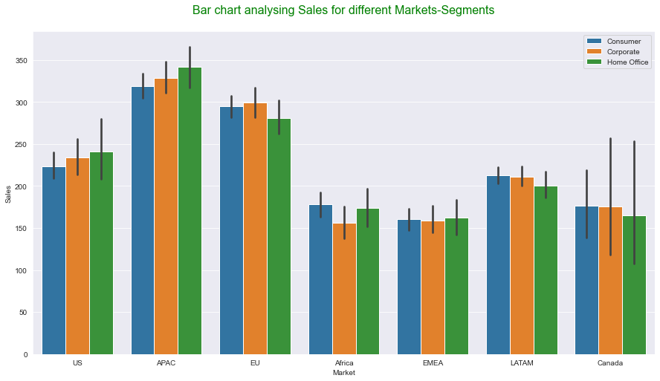

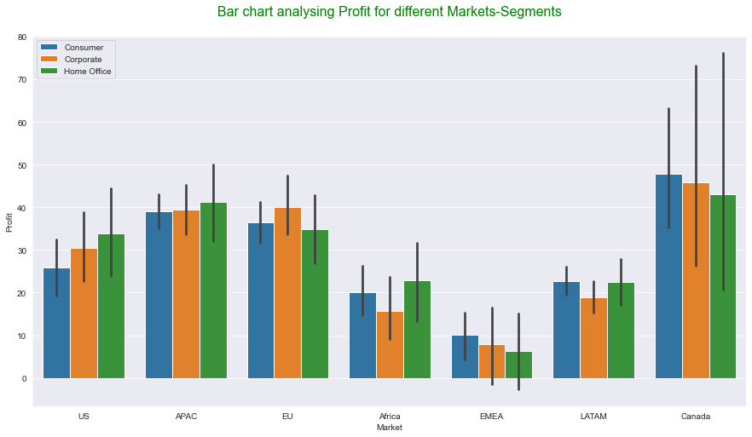

From the above graphs, we can see that **Canada-Consumer is the most profitable market-segment**and**APAC- Home Office is the leading Market-Segment combination in terms of Sales.**

As per the problem statement, we need to find 21 Market Segments by combining the respective 7 geographical markets for each of the 3 product segments. We create a column **Market-Segment** by combining 2 columns, Market and Segment.

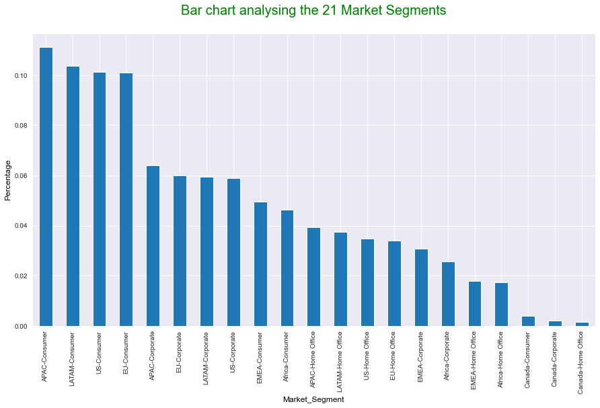

**Train-Test Split :**We divide the data such that train set contains 42 months and test set contains 6 months data.

**Consistently profitable market segment:**Coefficient of variation is a ratio of the standard deviation to mean. We need to find the market segment for which value of Coefficient of variation is the least for profit. This is because, less standard deviation means less variation in profit, which means more consistent are the profit figures for that region over the given period. We calculate the Coefficient of Variation for each of the 21 market segments for 42 months(train data) to decide which market segment is consistently profitable.

We find that **APAC-Consumer**is the market segment with least Coefficient of Variation. It means profit figures for APAC-Consumer market segment have been consistent over the train set period. Hence we choose this market segment to further calculate and predict the Sales Values.

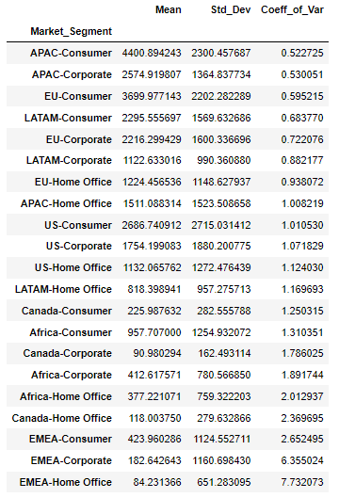

We filter the data for **APAC-Consumer**market segment and group the resultant data frame by Order date to get the time series data containing Order date and Sales. We call it data1.

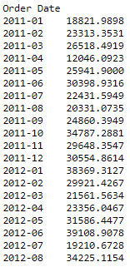

**Time series Decomposition**

Our time series data looks as follows:

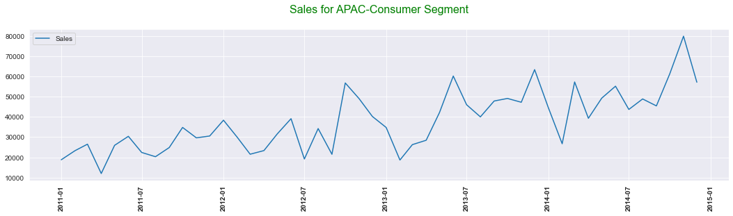

We perform the additive and multiplicative seasonal decomposition as follows:

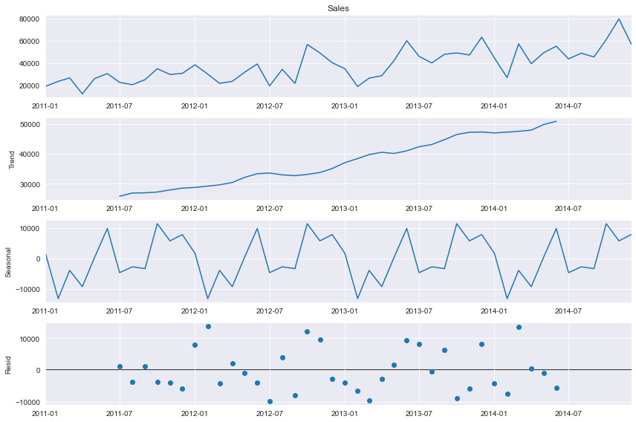

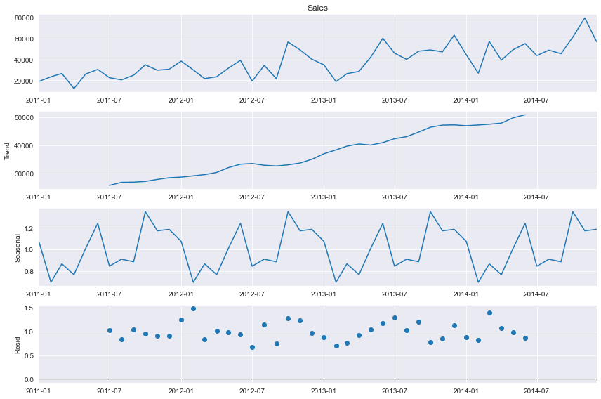

Left additive seasonal decomposition, right multiplicative seasonal decomposition

Clearly the data contains seasonal component. We build various Time Series Forecast models and compare the **RMSE** (Root Mean Squared Error) and **MAPE** (Mean Absolute Percentage Error) values for all the models. Lower values of RMSE and MAPE are desired to conclude that a model performs better. Accuracy is calculated as (100 — MAPE). Lower the MAPE value, higher is the accuracy.

We will now see various forecasting methods to forecast the sales values.

**Simple Time Series forecasting methods**

3 methods that fall under these are the Naive method, the Simple average method and the simple moving average method.

The Naive method simply carries forward the last observation. Simple average uses average of all observations for forecasting and Simple Moving average method uses moving averages for forecasting.

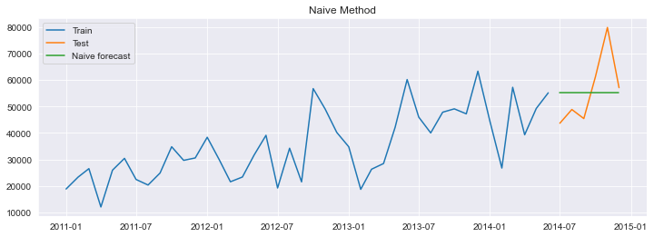

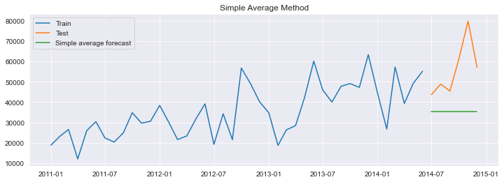

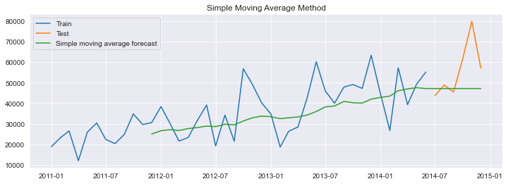

The RMSE and MAPE values are as shown below:

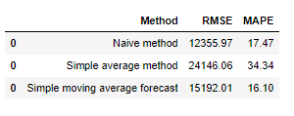

As we can see from the above figures, in the simple forecasting methods, Simple Moving Average method performs the best.

**Exponential Smoothing Techniques**

These are namely the Simple Exponential Smoothing technique, Holt’s method with trend and Holt Winter’s method.

While in simple average method, past observations are weighted equally, in the Simple exponential smoothing technique, the recent observations are given more weight than the past ones. It captures level in the data but doesn't capture trend or seasonality. The Holt’s method on the other hand can capture level and trend but not seasonality. The Holt Winter’s method can capture all level, trend and seasonality.

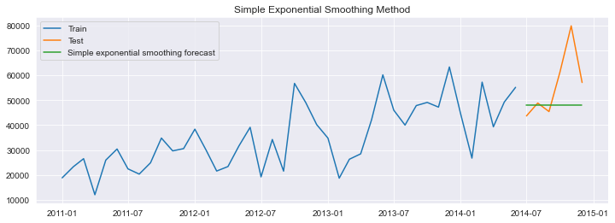

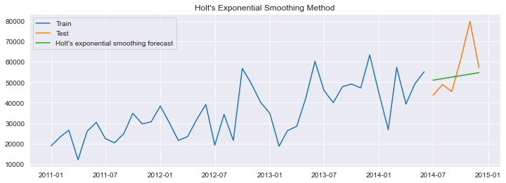

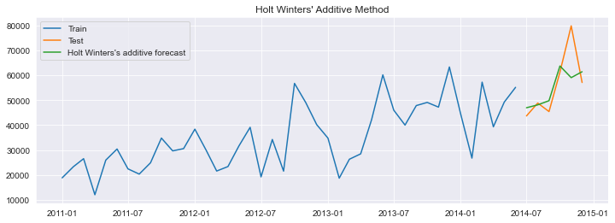

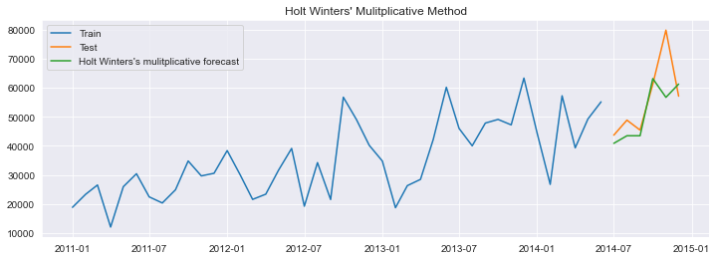

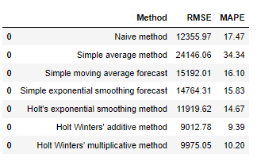

We conclude that the Holt Winters’ additive method in the smoothing techniques is able to forecast the sales closer to the actual values.The RMSE and MAPE values for this method are lower as compared to other model methods. This method is very well able to capture the trend and seasonality in the data.

**Auto Regressive methods**

In autoregressive methods, regression technique is used for forecasting the the future observations, using a linear combination of past observations. But for this the time series should follow 2 assumptions : Stationarity and Autocorrelation.

For a time series to be stationary, the mean, variance and co-variance should be constant. Autocorrelation helps us to know how a variable is influenced by its own lagged values.

There are 2 tests to confirm stationarity, as follows:

**Kwiatkowski-Phillips-Schmidt-Shin (KPSS) Test :**

1. Null Hypothesis (H 0 ): The series is stationary : p−value>0.05

2. Alternate Hypothesis (H a ): The series is not stationary : p−value≤0.05

**Augmented Dickey-Fuller (ADF) Test:**

1. Null Hypothesis (H0 ): The series is not stationary : p−value>0.05

2. Alternate Hypothesis (Ha ): The series is stationary : p−value≤0.05

We perform these tests on our time series data and conclude that the time series is not stationary. In order to make it stationary, we need to perform **Differencing**(making mean constant) and **Transformation**(making variance constant).

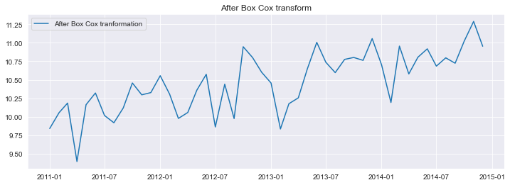

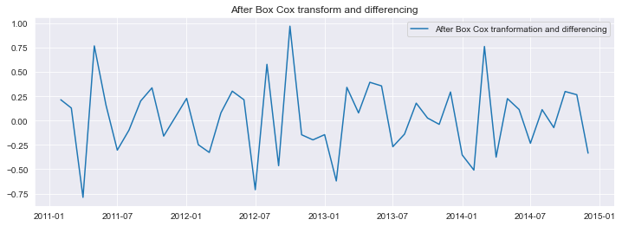

We perform train test split and proceed with the Auto Regressive techniques for forecasting.

**Auto regression method (AR)**

This method uses linear regression for predicting the future observation using one or more past observations.

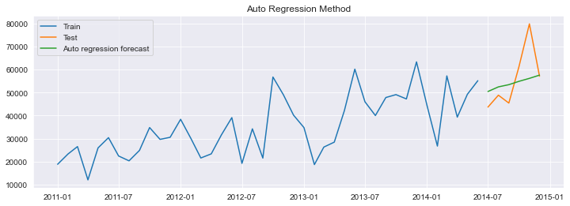

**Moving average method (MA)**

Here future values are forecasted using past forecast errors in a regression-like model.

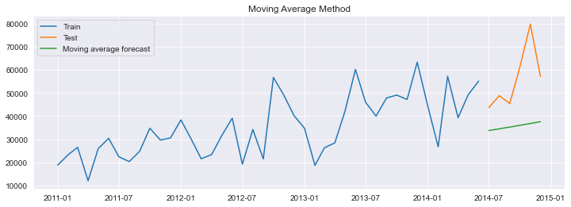

**Auto regression moving average method (ARMA)**

It’s a combination of AR and MA models.

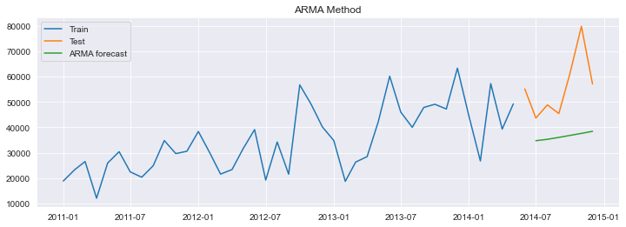

**Auto regressive integrated moving average (ARIMA)**

It is same as ARMA model, just has an additional integrated differencing component in it. Earlier, we applied both the box-cox transformation and differencing to the data, in order to make the time-series data stationary. Here, we are just applying box-cox before building the model and letting the model take care of the differencing i.e. the trend component itself.

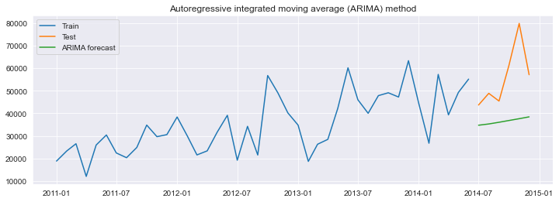

**Seasonal auto regressive integrated moving average (SARIMA)**

SARIMA is same as ARIMA, it just has an additional component of seasonality in it.

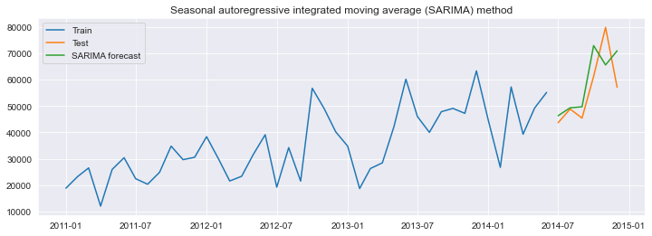

After implementing all the forecasting models, we calculate the RMSE and MAPE for all the methods.

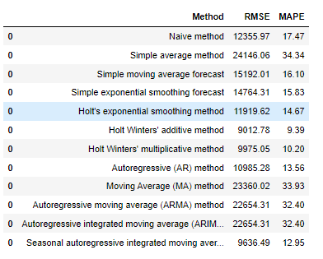

We conclude that, **Holt Winters’ additive method** and **Seasonal auto regressive integrated moving average (SARIMA) technique**are the best for forecasting the sales for the data. Both the methods have lower RMSE and MAPE values and are able to capture the trend and seasonality components, well, in the data.

This completes out analysis. Hope the article was informative and easy to understand. Also, I hope you enjoyed analyzing the colorful graphs that were included in the analysis.

125